

GRADUATE RECORD EXAMINATIONS®

Introduction to the Quantitative Reasoning Measure


Copyright © 2010 by Educational Testing Service. All rights reserved. ETS, the ETS logo, GRADUATE RECORD EXAMINATIONS, and GRE are registered trademarks of Educational Testing Service (ETS) in the United States and other countries.

Introduction to the Quantitative Reasoning Measure

Information for screen reader users:
This document has been created to be accessible to individuals who use screen readers. You may wish to consult the manual or help system for your screen reader to learn how best to take advantage of the features implemented in this document. Please consult the separate document, GRE Screen Reader Instructions.doc, for important details.
Note: This is the screen reader friendly edition of the Introduction to the Quantitative Measure. A downloadable large print version of this document is available from the GRE® website, as are other downloadable practice and test familiarization materials in large print and screen reader friendly formats. Tactile figure supplements for this document, along with additional accessible practice and test familiarization materials in other formats, are available from E T S Disability Services Monday to Friday 8:30 a m to 5 p m New York time, at 1-6 0 9-7 7 1-7 7 8 0, or 1-8 6 6-3 8 7-8 6 0 2 (toll free for test takers in the United States, U S Territories and Canada), or via email at stassd@ets.org.
The Quantitative Reasoning measure of the GRE revised General Test assesses your:
- basic mathematical skills
- understanding of elementary mathematical concepts
- ability to reason quantitatively and to model and solve problems with quantitative methods
Some of the questions in the measure are posed in real life settings, while others are posed in purely mathematical settings. The skills, concepts, and abilities are tested in the four content areas below.
Arithmetic topics include properties and types of integers, such as divisibility, factorization, prime numbers, remainders, and odd and even integers; arithmetic operations, exponents, and radicals; and concepts such as estimation, percent, ratio, rate, absolute value, the number line, decimal representation, and sequences of numbers.
Algebra topics include operations with exponents; factoring and simplifying algebraic expressions; relations, functions, equations, and inequalities; solving linear and quadratic equations and inequalities; solving simultaneous equations and inequalities; setting up equations to solve word problems; and coordinate geometry, including graphs of functions, equations, and inequalities, intercepts, and slopes of lines.
Geometry topics include parallel and perpendicular lines, circles, triangles, including isosceles, equilateral, and 30° - 60° - 90° triangles, quadrilaterals, other polygons, congruent and similar figures, three dimensional figures, area, perimeter, volume, the Pythagorean theorem, and angle measurement in degrees. The ability to construct proofs is not tested.
Data analysis topics include basic descriptive statistics, such as mean, median, mode, range, standard deviation, interquartile range, quartiles, and percentiles; interpretation of data in tables and graphs, such as line graphs, bar graphs, circle graphs, boxplots, scatterplots, and frequency distributions; elementary probability, such as probabilities of compound events and independent events; random variables and probability distributions, including normal distributions; and counting methods, such as combinations, permutations, and Venn diagrams. These topics are typically taught in high school algebra courses or introductory statistics courses. Inferential statistics is not tested.
The content in these areas includes high school mathematics and statistics at a level that is generally no higher than a second course in algebra; it does not include trigonometry, calculus, or other higher level mathematics. The publication Math Review for the GRE revised General Test, provides detailed information about the content of the Quantitative Reasoning measure.
The mathematical symbols, terminology, and conventions used in the Quantitative Reasoning section are those that are standard at the high school level. For example, the positive direction of a number line is to the right, distances are nonnegative, and prime numbers are greater than 1. Whenever nonstandard notation is used in a question, it is explicitly introduced in the question.
In addition to conventions, there are some assumptions about numbers and geometric figures that are used in the Quantitative Reasoning measure. Two of these assumptions are:
1. all numbers used are real numbers, and
2. geometric figures are not necessarily drawn to scale.
More about conventions and assumptions appears in the publication Mathematical Conventions for the Quantitative Reasoning Measure GRE revised General Test.

Quantitative Reasoning Question Types
The Quantitative Reasoning section has four types of questions:
1 Quantitative Comparison
2 Multiple choice—Select One
3 Multiple choice—Select One or More
4 Numeric Entry
Each question appears either independently as a discrete question or as part of a set of questions called a Data Interpretation set. All of the questions in a Data Interpretation set are based on the same data presented in tables, graphs, or other displays of data.
You are allowed to use a basic calculator on the Quantitative Reasoning measure of the test. In the standard computer based version of the test, a basic calculator is provided on-screen. In other editions of the test, a handheld basic calculator is provided. No other calculator may be used except as an approved accommodation. General information about using a calculator and specific information on using the handheld basic calculator are in the Using the Calculator section of this document. Information about using the on screen calculator in the standard computer based version of the test appears in Appendix B of this document.

Quantitative Comparison Questions

Description
Questions of this type ask you to compare two quantities, Quantity A and Quantity B, and then determine which of the following statements describes the comparison.
A. Quantity A is greater.
B. Quantity B is greater.
C. The two quantities are equal.
D. The relationship cannot be determined from the information given.

Tips for Answering
1. Become familiar with the answer choices. Quantitative Comparison questions always have the same answer choices, so get to know them, especially the last answer choice, “The relationship cannot be determined from the information given”. Never select this last choice if it is clear that the values of the two quantities can be determined by computation. Also, if you determine that one quantity is greater than the other, make sure you carefully select the corresponding answer choice so as not to reverse the first two answer choices.
2. Avoid unnecessary computations. Don’t waste time performing needless computations in order to compare the two quantities. Simplify, transform, or estimate one or both of the given quantities only as much as is necessary to compare them.
3. Remember that geometric figures are not necessarily drawn to scale. If any aspect of a given geometric figure is not fully determined, try to redraw the figure, keeping those aspects that are completely determined by the given information fixed, but changing the aspects of the figure that are not determined. Examine the results. What variations are possible in the relative lengths of line segments or measures of angles?
4. Plug in numbers. If one or both of the quantities are algebraic expressions, you can substitute easy numbers for the variables and compare the resulting quantities in your analysis. Consider all kinds of appropriate numbers before you give an answer: for example, zero, positive and negative numbers, small and large numbers, fractions and decimals. If you see that Quantity A is greater than Quantity B in one case and Quantity B is greater than Quantity A in another case, choose “The relationship cannot be determined from the information given”.
5. Simplify the comparison. If both quantities are algebraic or arithmetic expressions and you cannot easily see a relationship between them, you can try to simplify the comparison. Try a step by step simplification that is similar to the steps involved when you solve the equation 5 = 4x + 3 for x, or that is similar to the steps involved when you determine that the inequality
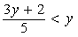the fraction with numerator 3y +2 and denominator 5 is less than y
is equivalent to the simpler inequality 1 is less than y. Begin by setting up a comparison involving the two quantities, as follows:
Quantity A, followed by a question mark symbol, followed by Quantity B
where the question mark symbol is a “placeholder” that could represent the relationship greater than, the relationship less than, or the relationship equal to, or could represent the fact that the relationship cannot be determined from the information given. Then try to simplify the comparison, step by step, until you can determine a relationship between simplified quantities. For example, you may conclude after the last step that the question mark symbol represents equal to. Based on this conclusion, you may be able to compare Quantities A and B. To understand this strategy more fully, see sample questions 6 to 9.

Sample Questions
Directions:
Compare Quantity A and Quantity B, using the additional information given, if any. Select one of the following four answer choices.
A. Quantity A is greater.
B. Quantity B is greater.
C. The two quantities are equal.
D. The relationship cannot be determined from the information given.
A symbol that appears more than once in a question has the same meaning throughout the question.
Sample Question 1.
Quantity A: 2 times 6
Quantity B: 2 + 6
A. Quantity A is greater.
B. Quantity B is greater.
C. The two quantities are equal.
D. The relationship cannot be determined from the information given.
Explanation
Since 2 times 6, or 12, is greater than 2 + 6, or 8, Quantity A is greater than Quantity B. Thus, the correct answer is choice A, Quantity A is greater.
Sample Question 2.
Lionel is younger than Maria.
Quantity A: Twice Lionel’s age
Quantity B: Maria’s age
A. Quantity A is greater.
B. Quantity B is greater.
C. The two quantities are equal.
D. The relationship cannot be determined from the information given.
Explanation
If Lionel’s age is 6 years and Maria’s age is 10 years, then Quantity A is greater, but if Lionel’s age is 4 years and Maria’s age is 10 years, then Quantity B is greater. Thus, the relationship cannot be determined. The correct answer is choice D, the relationship cannot be determined from the information given.
Sample Question 3.
Quantity A: 54% of 360
Quantity B: 150
A. Quantity A is greater.
B. Quantity B is greater.
C. The two quantities are equal.
D. The relationship cannot be determined from the information given.
Explanation
This question asks you to compare Quantity A: 54% of 360, and Quantity B: 150.
Without doing the exact computation, you can see that 54 percent of 360 is greater than 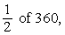 one half of 360, which is 180, and 180 is greater than Quantity B, 150. Thus, the correct answer is choice A, Quantity A is greater.
Sample Question 4.
Refer to figure 1.
.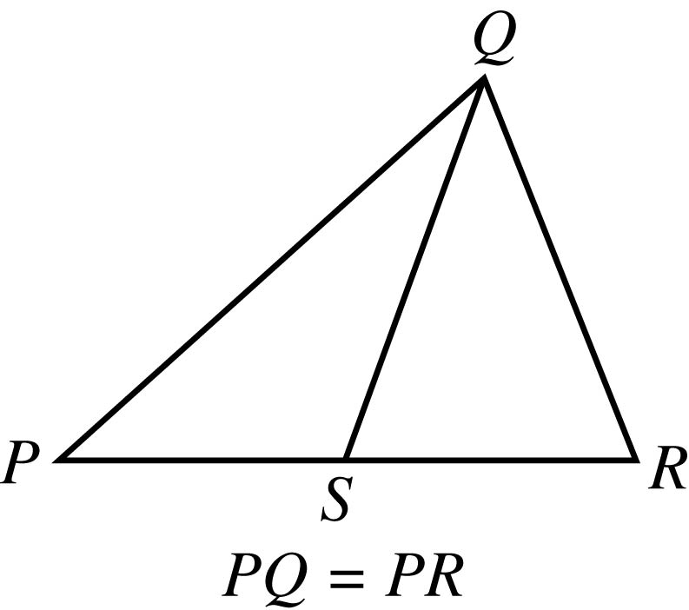
Figure 1

Begin skippable figure description.
The figure shows triangle PQR, where P is the leftmost vertex of the horizontal side PR and vertex Q is above PR. Point S lies on horizontal side PR. Point S appears to be the midpoint of PR. Line segment QS is drawn from vertex Q to point S. The lengths of PS and SR appear to be equal.
It is given that the length of PQ is equal to the length of PR.

End skippable figure description.
Quantity A: The length of PS
Quantity B: The length of SR
A. Quantity A is greater.
B. Quantity B is greater.
C. The two quantities are equal.
D. The relationship cannot be determined from the information given.
Explanation
This question asks you to compare Quantity A: the length of PS, and Quantity B: the length of SR.
From Figure 1, you know that PQR is a triangle and that point S is between points P and R, so the length of PS is less than the length of PR and the length of SR is less than the length of PR. You are also given that the length of PQ is equal to the length of PR. However, this information is not sufficient to compare the length of PS and the length of SR. Furthermore, because the figure is not necessarily drawn to scale, you cannot determine the relative lengths of PS and SR from the figure, though the lengths may appear to be equal. The position of S can vary along side PR anywhere between P and R. Below are two possible variations of Figure 1, each of which is drawn to be consistent with the information that the length of PQ is equal to the length of PR.
Refer to figure 2 and figure 3.
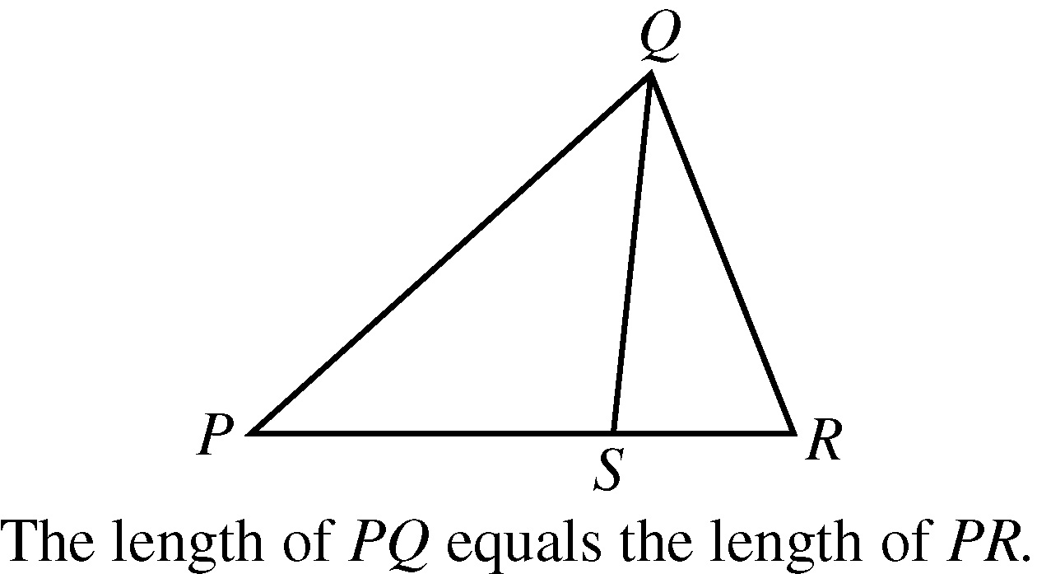
Figure 2
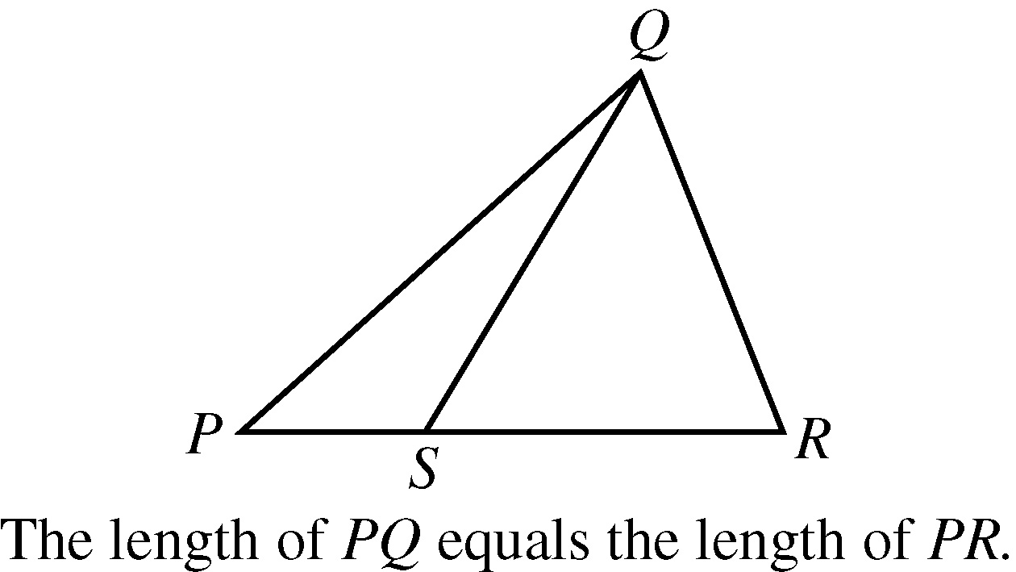
Figure 3

Begin skippable figure description.
In figure 2, instead of appearing to be the midpoint of PR, S appears to be closer to R than to P and the length of PS appears to be greater than the length of SR.
In figure 3, instead of appearing to be the midpoint of PR, S appears to be closer to P than to R and the length of PS appears to be less than the length of SR.

End skippable figure description.
Note that Quantity A, the length of PS, is greater in Figure 2 and Quantity B, the length of SR, is greater in Figure 3. Thus, the correct answer is choice D, the relationship cannot be determined from the information given.
Sample Question 5.
y = 2 times the square of x + 7x, minus 3
Quantity A: x
Quantity B: y
A. Quantity A is greater.
B. Quantity B is greater.
C. The two quantities are equal.
D. The relationship cannot be determined from the information given.
Explanation
This question asks you to compare Quantity A: x, and Quantity B: y.
If x = 0, then 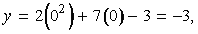 y = 2 times, open parenthesis, 0 squared close parenthesis, +,7 times open parenthesis 0, close parenthesis, minus 3, which is equal to minus 3, so in this case, x is greater than y; but if x = 1, then 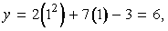 y = 2 times, open parenthesis, 1 squared, close parenthesis, + 7 times, open parenthesis, 1 close parenthesis, minus 3, which is equal to 6, so in that case, y is greater than x. Thus, the correct answer is choice D, the relationship cannot be determined from the information given.
Note that plugging numbers into expressions may not be conclusive. It is conclusive, however, if you get different results after plugging in different numbers: the conclusion is that the relationship cannot be determined from the information given. It is also conclusive if there are only a small number of possible numbers to plug in and all of them yield the same result, say, that Quantity B is greater.
Now suppose that there are an infinite number of possible numbers to plug in. If you plug many of them in and each time the result is, for example, that Quantity A is greater, you still cannot conclude that Quantity A is greater for every possible number that could be plugged in. Further analysis would be necessary and should focus on whether Quantity A is greater for all possible numbers or whether there are numbers for which Quantity A is not greater.
The following sample questions focus on simplifying the comparison.
Sample Question 6.
It is given that y is greater than 4.
Quantity A: 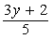the fraction with numerator 3y +2 and denominator 5
Quantity B: y
A. Quantity A is greater.
B. Quantity B is greater.
C. The two quantities are equal.
D. The relationship cannot be determined from the information given.
Explanation
Set up the initial comparison of Quantity A and Quantity B using a placeholder question mark symbol as follows:
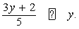the fraction with numerator 3y + 2 and denominator 5, followed by a question mark symbol, followed by y.
Then simplify:
Step 1: Multiply both sides by 5 to get 3y +2, followed by the question mark symbol, followed by 5y
Step 2: Subtract 3y from both sides to get 2, followed by the question mark symbol, followed by 2y
Step 3: Divide both sides by 2 to get 1, followed by the question mark symbol, followed by y
The comparison is now simplified as much as possible. In order to compare 1 and y, note that along with Quantities A and B you were given the additional information y is greater than 4. It follows from y is greater than 4, that y is greater than 1, or 1 is less than y, so that in the comparison 1, followed by the question mark symbol, followed by y, the question mark symbol represents less than (<):1 is less than y.
However, the problem asks for a comparison between Quantity A and Quantity B, not a comparison between 1 and y. To go from the comparison between 1 and y to a comparison between Quantities A and B, start with the last comparison, 1 is less than y, and carefully consider each simplification step in reverse order to determine what each comparison implies about the preceding comparison, all the way back to the comparison between Quantities A and B if possible. Since step 3 was “divide both sides by 2”, multiplying both sides of the comparison 1 is less than y by 2, implies the preceding comparison 2 is less than 2y, thus reversing step 3. Each simplification step can be reversed as follows:
Step 3 was “Divide both sides by 2”. To reverse this step, you need to multiply both sides by 2. The result of reversing step 3 is 2 is less than 2y.
Step 2 was “Subtract 3y from both sides”. To reverse the step you need to add 3y to both sides. The result of reversing step 2 is 3y + 2 is less than 5y.
Step 1 was “Multiply both sides by 5”. To reverse this step, divide both sides by 5. The result of reversing step 1 is 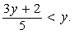 the fraction with numerator 3y + 2 and denominator 5 is less than y.
When each step is reversed, the relationship remains less than (<), so Quantity A is less than Quantity B. Thus, the correct answer is choice B, Quantity B is greater.
While some simplification steps like subtracting 3 from both sides or dividing both sides by 10 are always reversible, it is important to note that some steps, like squaring both sides, may not be reversible.
Also, note that when you simplify an inequality, the steps of multiplying or dividing both sides by a negative number change the direction of the inequality; for example, if x is less than y, then negative x is greater than negative y. So the relationship in the final, simplified inequality may be the opposite of the relationship between Quantities A and B. This is another reason to consider the impact of each step carefully.
Sample Question 7.
Quantity A: 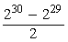the fraction with numerator 2 to the power 30, minus, 2 to the power 29, and denominator 2
Quantity B: 2 to the power 28
A. Quantity A is greater.
B. Quantity B is greater.
C. The two quantities are equal.
D. The relationship cannot be determined from the information given.
Explanation
Set up the initial comparison of Quantity A and Quantity B:
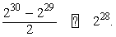the fraction with numerator 2 to the power 30, minus, 2 to the power 29, and denominator 2, followed by a made up question mark symbol, followed by 2 to the power 28.
Then simplify:
Step 1: Multiply both sides by 2 to get 2 to the power 30, minus, 2 to the power 29, followed by the question mark symbol, followed by 2 to the power 29.
Step 2: Add 2 to the power 29 to both sides to get 2 to the power 30, followed by the question mark symbol, followed by 2 to the power 29, +, 2 to the power 29.
Step 3: Simplify the right-hand side using the fact that 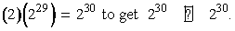 2 times, open parenthesis, 2 to the power 29, close parenthesis, = 2 to the power 30, to get 2 to the power 30, followed by the question mark symbol, followed by 2 to the power 30.
The resulting relationship is equal to (=). In reverse order, each simplification step implies equal to in the preceding comparison. So Quantities A and B are also equal. Thus, the correct answer is choice C, the two quantities are equal.
Sample Question 8.
Quantity A: x squared, + 1
Quantity B: 2x, minus 1
A. Quantity A is greater.
B. Quantity B is greater.
C. The two quantities are equal.
D. The relationship cannot be determined from the information given.
Explanation
Set up the initial comparison of Quantity A and Quantity B:
x squared + 1, followed by a made up question mark symbol, followed by 2x, minus 1.
Then simplify by noting that the quadratic polynomial x squared, minus 2x, + 1 can be factored:
Step 1: Subtract 2x from both sides to get x squared, minus 2x, + 1, followed by the question mark symbol, followed by negative 1.
Step 2: Factor the left hand side to get open parenthesis, x minus 1, close parenthesis, squared, followed by the question mark symbol, followed by negative 1.
The left hand side of the comparison is the square of a number. Since the square of a number is always greater than or equal to 0, and 0 is greater than negative 1, the simplified comparison is the inequality open parenthesis, x squared minus 1, close parenthesis, squared, is greater than negative 1 and the resulting relationship is greater than (>). In reverse order, each simplification step implies the inequality greater than (>) in the preceding comparison. Therefore, Quantity A is greater than Quantity B. The correct answer is choice A, Quantity A is greater.
Sample Question 9.
It is given that w is greater than 1.
Quantity A: 7w minus 4
Quantity B: 2w + 5
A. Quantity A is greater.
B. Quantity B is greater.
C. The two quantities are equal.
D. The relationship cannot be determined from the information given.
Explanation
Set up the initial comparison of Quantity A and Quantity B:
7w minus 4, followed by a made up question mark symbol, followed by 2w + 5
Then simplify:
Step 1: Subtract 2w from both sides and add 4 to both sides to get 5w, followed by the question mark symbol, followed by the number 9.
Step 2: Divide both sides by 5 to get 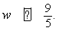 w, followed by the question mark symbol, followed by the fraction 9 over 5.
The comparison cannot be simplified any further. Although you are given that w is greater than 1, you still don’t know how w compares to the fraction 9 over 5, or 1.8. For example, if w = 1.5, then w is less than 1.8, but if w = 2, then w is greater than 1.8. In other words, the relationship between w and the fraction 9 over 5 cannot be determined. Note that each of these simplification steps is reversible, so in reverse order, each simplification step implies that the relationship cannot be determined in the preceding comparison. Thus, the relationship between Quantities A and B cannot be determined. The correct answer is choice D, the relationship cannot be determined from the information given.
The strategy of simplifying the comparison works most efficiently when you note that a simplification step is reversible while actually taking the step. Here are four common steps that are always reversible:
1 Adding any number or expression to both sides of a comparison
2 Subtracting any number or expression from both sides
3 Multiplying both sides by any nonzero number or expression
4 Dividing both sides by any nonzero number or expression
Remember that if the relationship is an inequality, multiplying or dividing both sides by any negative number or expression will yield the opposite inequality. Be aware that some common operations like squaring both sides are generally not reversible and may require further analysis using other information given in the question in order to justify reversing such steps.

Multiple-choice—Select One Questions
Description
These questions are multiple choice questions that ask you to select only one answer choice from a list of five choices.

Tips for Answering
1. Use the fact that the answer is there. If your answer is not one of the five answer choices given, you should assume that your answer is incorrect and do the following:
A. Reread the question carefully; you may have missed an important detail or misinterpreted some information.
B. Check your computations; you may have made a mistake, such as miskeying a number on the calculator.
C. Reevaluate your solution method; you may have a flaw in your reasoning.
2. Examine the answer choices. In some questions you are asked explicitly which of the choices has a certain property. You may have to consider each choice separately or you may be able to see a relationship between the choices that will help you find the answer more quickly. In other questions, it may be helpful to work backward from the choices, say, by substituting the choices in an equation or inequality to see which one works. However, be careful, as that method may take more time than using reasoning.
3. For questions that require approximations, scan the answer choices to see how close an approximation is needed. In other questions, too, it may be helpful to scan the choices briefly before solving the problem to get a better sense of what the question is asking. If computations are involved in the solution, it may be necessary to carry out all computations exactly and round only your final answer in order to get the required degree of accuracy. In other questions, you may find that estimation is sufficient and will help you avoid spending time on long computations.

Sample Questions
Directions: These questions have five answer choices. For each question, select the best one of the answer choices given.
1. If 5x + 32 = 4 minus 2x, what is the value of x ?
A negative 4
B. negative 3
C. 4
D. 7
E. 12
Explanation
Solving the equation for x, you get 7x = negative 28, and so x = negative 4. The correct answer is choice A, negative 4.
2. Which of the following numbers is farthest from the number 1 on the number line?
A. negative 10
B. negative 5
C. 0
D. 5
E. 10
Explanation
Circling each of the answer choices in a sketch of the number line, as shown in Figure 4
Circling each of the answer choices in a sketch of the number line, as shown in Figure 4 below, shows that of the given numbers, negative 10 is the greatest distance from 1.

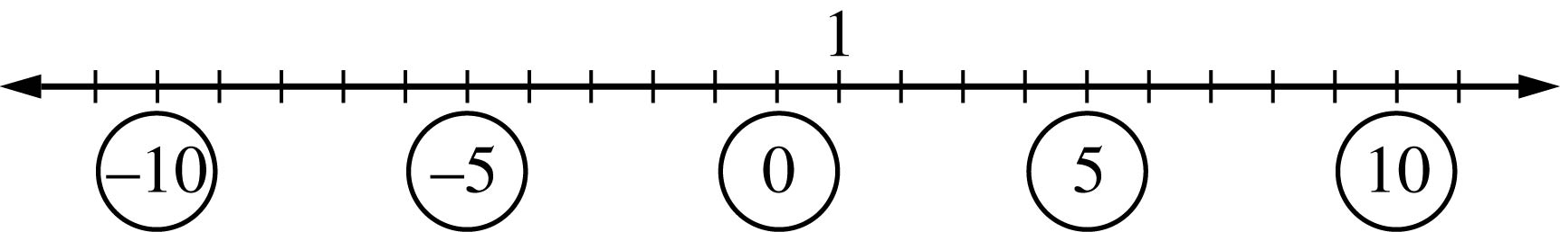
Figure 4

Begin figure description.
The figure is a number line with 23 equally spaced tick marks labeled with the integers from negative 11 through positive 11. Going from left to right, the 5 evenly spaced integers negative 10, negative 5, 0, 5 and 10 are circled. The integer 1 is 1 tick mark to the right of 0. There is an arrow pointing to the integer 1.

End figure description.
Another way to answer the question is to remember that the distance between two numbers on the number line is equal to the absolute value of the difference of the two numbers. For example, the distance between negative 10 and 1 is the absolute value of negative 10 minus one, which equals 11, and the distance between 10 and 1 is the absolute value of 10 minus one, which equals the absolute value of 9, which equals 9. The correct answer is choice A, negative 10.
3.
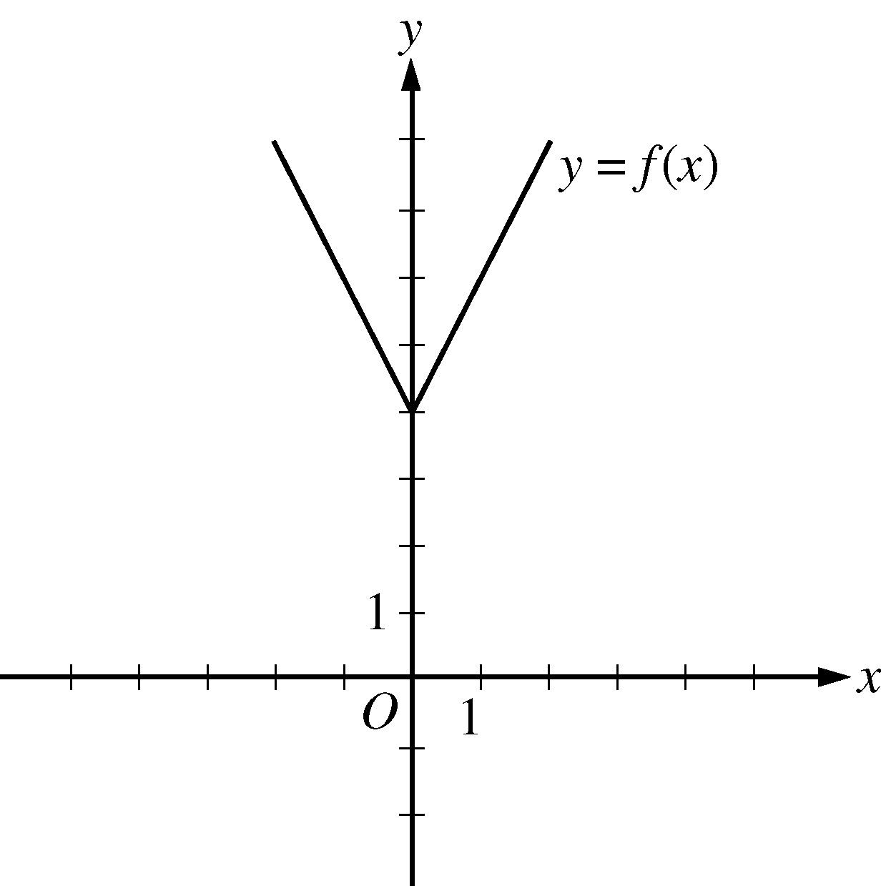
Figure 5

Begin skippable figure description.
The figure accompanying this question shows the graph in the x y plane of the function f of x = the absolute value of 2x, end absolute value, + 4. There are equally spaced tick marks along the x axis and along the y axis. The first tick mark to the right of the origin, and the first tick mark above the origin, are both labeled 1.
The graph of the function f is in the shape of the letter V. It is above the x axis and is symmetric with respect to the y axis.
The lowest point on the graph of f is the point 0 comma 4, which is located on y axis at the fourth tick mark above the origin.
Going leftward from the point 0 comma 4, the graph of f is a line that slants upward, passing through the point negative 2 comma 8.
Going rightward from the point 0 comma 4, the graph of f is a line that slants upward, passing through the point 2 comma 8.

End skippable figure description.
The figure above shows the graph of a function f, defined by f of x = the absolute value of 2x, end absolute value, + 4, for all numbers x. For which of the following functions g defined for all numbers x does the graph of g intersect the graph of f ?
A. g of x = x minus 2
B. g of x = x + 3
C. g of x = 2x minus 2
D. g of x = 2x + 3
E g of x = 3x minus 2
Explanation
You can see that all five choices are linear functions whose graphs are lines with various slopes and y intercepts. The graph of choice A is a line with slope 1 and y intercept negative 2, shown in Figure 6.
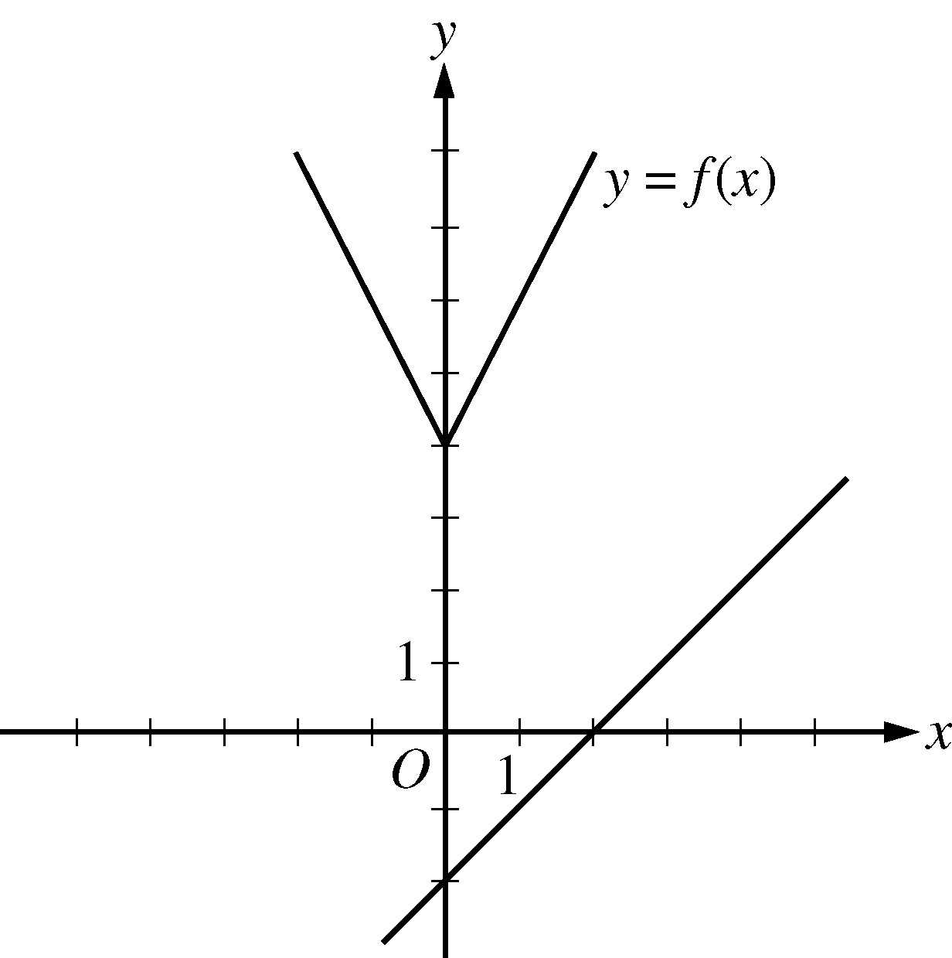
Figure 6

Begin figure description.
Figure 6 is the same as figure 5 except that the graph of the line with slope 1 and y intercept negative 2 has been added. The line slants upward as you go from left to right and intersects the x axis at 2. The line is below the graph of y = f of x.

End figure description
It is clear that this line will not intersect the graph of f to the left of the y axis. To the right of the y axis, the graph of f is a line with slope 2, which is greater than slope 1. Consequently, as the value of x increases, the value of y increases faster for f than for g, and therefore the graphs do not intersect to the right of the y axis. Choice B is similarly ruled out. Note that if the y intercept of either of the lines in choices A and B were greater than or equal to 4 instead of less than 4, they would intersect the graph of f.
Choices C and D are lines with slope 2 and y intercepts less than 4. Hence, they are parallel to the graph of f (to the right of the y axis) and therefore will not intersect it. Any line with a slope greater than 2 and a y intercept less than 4, like the line in choice E, will intersect the graph of f (to the right of the y axis). The correct answer is choice E, g of x = 3x minus 2.
4. A car got 33 miles per gallon using gasoline that cost $2.95 per gallon. What was the approximate cost, in dollars, of the gasoline used in driving the car 350 miles?
A. $10
B. $20
C. $30
D. $40
E $50
Explanation
Scanning the answer choices indicates that you can do at least some estimation and still answer confidently. The car used 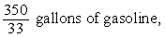 350 over 33 gallons of gasoline, so the cost was 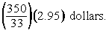 open parenthesis, 350 over 33, close parenthesis, times 2.95 dollars. You can estimate the product 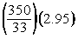 open parenthesis, 350 over 33, close parenthesis, times 2.95 by estimating 350 over 33 a little low, 10, and estimating 2.95 a little high, 3, to get approximately 10 times 3 = 30 dollars. You can also use the calculator to compute a more exact answer and then round the answer to the nearest 10 dollars, as suggested by the answer choices. The calculator yields the decimal 31.287..., which rounds to 30 dollars. Thus, the correct answer is choice C, $30.
5. A certain jar contains 60 jelly beans: 22 white, 18 green, 11 yellow, 5 red, and 4 purple. If a jelly bean is to be chosen at random, what is the probability that the jelly bean will be neither red nor purple?
A. 0.09
B. 0.15
C. 0.54
D. 0.85
E 0.91
Explanation
Since there are 5 red and 4 purple jelly beans in the jar, there are 51 that are neither red nor purple and the probability of selecting one of these is 51 over 60. Since all of the answer choices are decimals, you must convert the fraction to its decimal equivalent, 0.85. Thus, the correct answer is choice D, 0.85.

Multiple-choice—Select One or More Questions
Description
These questions are multiple choice questions that ask you to select one or more answer choices from a list of choices. A question may or may not specify the number of choices to select.

Tips for Answering
1. Note whether you are asked to indicate a specific number of answer choices or all choices that apply. In the latter case, be sure to consider all of the choices, determine which ones are correct, and select all of those and only those choices. Note that there may be only one correct choice.
2. In some questions that involve inequalities that limit the possible values of the answer choices, it may be efficient to determine the least and/or the greatest possible value. Knowing the least and/or greatest possible value may enable you to quickly determine all of the choices that are correct.
3. Avoid lengthy calculations by recognizing and continuing numerical patterns.

Sample Questions
Directions: Select one or more answer choices according to the specific question directions.
If the question does not specify how many answer choices to select, select all that apply.
- The correct answer may be just one of the choices or may be as many as all of the choices, depending on the question.
- No credit is given unless you select all of the correct choices and no others.
If the question specifies how many answer choices to select, select exactly that number of choices.
1. Which two of the following numbers have a product that is greater than 60 ?
A. negative 9
B. negative 7
C. 6
D. 8
Explanation
For this type of question, it is often possible to exclude some pairs of answer choices. In this question, the product must be positive, so the only possible products are either negative 7 times negative 9 = 63, or 6 times 8 = 48. The correct answer consists of choices A, negative 9 and B, negative 7.
2. Which of the following integers are multiples of both 2 and 3 ?
Indicate all such integers.
A. 8
B. 9
C. 12
D. 18
E. 21
F. 36
Explanation
You can first identify the multiples of 2, which are 8, 12, 18, and 36, and then among the multiples of 2 identify the multiples of 3, which are 12, 18, and 36. Alternatively, if you realize that every number that is a multiple of 2 and 3 is also a multiple of 6, you can check which choices are multiples of 6. The correct answer consists of choices C, 12, D, 18, and F, 36.
3. Each employee of a certain company is in either Department X or Department Y, and there are more than twice as many employees in Department X as in Department Y. The average (arithmetic mean) salary is $25,000 for the employees in Department X and is $35,000 for the employees in Department Y. Which of the following amounts could be the average salary for all of the employees in the company?
Indicate all such amounts.
A. $26,000
B. $28,000
C. $29,000
D. $30,000
E. $31,000
F. $32,000
G. $34,000
Explanation
One strategy for answering this kind of question is to find the least and/or greatest possible value. Clearly the average salary is between $25,000 and $35,000, and all of the answer choices are in this interval. Since you are told that there are more employees with the lower average salary, the average salary of all employees must be less than the average of $25,000 and $35,000, which is $30,000. If there were exactly twice as many employees in Department X as in Department Y, then the average salary for all employees would be, to the nearest dollar, the following weighted mean,
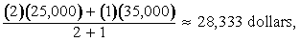
the fraction with numerator 2 times 25,000, +, 1 times 35,000, and denominator 2 + 1, which is approximately 28,333 dollars,
where the weight for $25,000 is 2 and the weight for $35,000 is 1. Since there are more than twice as many employees in Department X as in Department Y, the actual average salary must be even closer to $25,000 because the weight for $25,000 is greater than 2. This means that $28,333 is the greatest possible average. Among the choices given, the possible values of the average are therefore $26,000 and $28,000. Thus, the correct answer consists of choices A, $26,000 and B, $28,000.
Intuitively, you might expect that any amount between $25,000 and $28,333 is a possible value of the average salary. To see that $26,000 is possible, in the weighted mean above, use the respective weights 9 and 1 instead of 2 and 1. To see that $28,000 is possible, use the respective weights 7 and 3.
4. Which of the following could be the units digit of 57 to the power n, where n is a positive integer?
Indicate all such digits.
A. 0
B. 1
C. 2
D. 3
E. 4
F. 5
G. 6
H. 7
I. 8
J. 9
Explanation
The units digit of 57 to the power n is the same as the units digit of 7 to the power n for all positive integers n. To see why this is true for n = 2, compute 57 to the power 2 by hand and observe how its units digit results from the units digit of 7 to the power 2. Because this is true for every positive integer n, you need to consider only powers of 7. Beginning with n = 1 and proceeding consecutively, the units digits of 7, 7 to the power 2, 7 to the power 3, 7 to the power 4, and 7 to the power 5 are 7, 9, 3, 1, and 7, respectively. In this sequence, the first digit, 7, appears again, and the pattern of four digits, 7, 9, 3, 1, repeats without end. Hence, these four digits are the only possible units digits of 7 to the power n and therefore of 57 to the power n. The correct answer consists of the four choices B, D, H, and J, which are 1, 3, 7, and 9, respectively.

Numeric Entry Questions

Description
Questions of this type either ask you to enter your answer as an integer or a decimal or ask you to enter your answer as a fraction. In the standard computer based version of the test, use the computer mouse and keyboard to enter your answer. Instructions for entering answers in the standard computer based version of the test can be found in Appendix A of this document. Instructions for entering answers in the Large Print, Braille, and audio editions of the test are included in corresponding Practice Test editions.

Tips for Answering
1. Make sure you answer the question that is asked. Since there are no answer choices to guide you, read the question carefully and make sure you provide the type of answer required. Sometimes there will be labels before or after the answer box to indicate the appropriate type of answer. Pay special attention to units such as feet or miles, to orders of magnitude such as millions or billions, and to percents as compared with decimals.
2. If you are asked to round your answer, make sure you round to the required degree of accuracy. For example, if an answer of 46.7 is to be rounded to the nearest integer, you need to enter the number 47. If your solution strategy involves intermediate computations, you should carry out all computations exactly and round only your final answer in order to get the required degree of accuracy. If no rounding instructions are given, enter the exact answer.
3. Examine your answer to see if it is reasonable with respect to the information given. You may want to use estimation or another solution path to double check your answer.

Sample Questions
Directions: Enter your answer in the answer space below the question.
- Equivalent forms of the correct answer, such as 2.5 and 2.50, are all correct. Fractions do not need to be reduced to lowest terms.
- Enter the exact answer unless the question asks you to round your answer.
1. One pen costs $0.25 and one marker costs $0.35. At those prices, what is the total cost of 18 pens and 100 markers?
$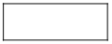 The answer space consists of a dollar sign, followed by a box for the answer.
Explanation
Multiplying $0.25 by 18 yields $4.50, which is the cost of the 18 pens; and multiplying $0.35 by 100 yields $35.00, which is the cost of the 100 markers. The total cost is therefore $4.50 + $35.00 = $39.50. Equivalent decimals, such as $39.5 or $39.500, are considered correct. Thus, the correct answer is $39.50 (or equivalent).
Note that the dollar symbol is in front of the answer box, so the symbol $ does not need to be entered in the box. In fact, only numbers, a decimal point, and a negative sign can be entered in the answer space.
2. Rectangle R has length 30 and width 10, and square S has length 5. The perimeter of S is what fraction of the perimeter of R ?
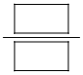The answer space consists of a fraction bar, and two boxes, one above and one below the fraction bar.
Explanation
The perimeter of R is 30 + 10 + 30 + 10 = 80, and the perimeter of S is 4 times 5 = 20. Therefore, the perimeter of S is 20 over 80 of the perimeter of R. To enter the answer 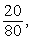 20 over 80, you should enter the numerator 20 in the box above fraction bar and the denominator 80 in the box below the fraction bar. Because the fraction does not need to be reduced to lowest terms, any fraction that is equivalent to 20 over 80 is also considered correct, as long as it fits in the boxes. For example, both of the fractions 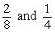 2 eighths and 1 fourth are considered correct. Thus, the correct answer is 20 over 80 (or equivalent).

3. This question is based on the following 3 column table, which summarizes the results of a used car auction. The first row of the table contains column headers. The header for the second column is “Small Cars” and the header for the third column is “Large Cars”. There is no header for the first column. There are 3 rows of data in the table.

 | Small Cars | Large Cars
Number of cars offered | 32 | 23
Number of cars sold | 16 | 20
Projected sales total for cars offered (in thousands) | $70 | $150
Actual sales total (in thousands) | $41 | $120
Figure 7
For the large cars sold at an auction, which is summarized in the table in figure 7, what was the average sale price per car?
$ The answer space consists of a dollar sign, followed by a box for the answer.
Explanation
From the table in Figure 7, you see that the number of large cars sold was 20 and the sales total for large cars was $120,000 (not $120). Thus the average sale price per car was 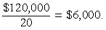 $120,000 over 20 = $6,000. The correct answer is $6,000 (or equivalent).
(Note that the comma in 6,000 will appear automatically in the answer box in the computer based version of the test.)

4. A merchant made a profit of $5 on the sale of a sweater that cost the merchant $15. What is the profit expressed as a percent of the merchant’s cost?
Give your answer to the nearest whole percent.
% The answer space consists of a box for the answer followed by the % sign.
Explanation
The percent profit is 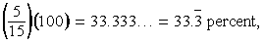 open parenthesis, 5 over 15, close parenthesis, times 100, which equals 33.333..., which equals 33 point 3 with a bar over it, percent, which is 33%, to the nearest whole percent. Thus, the correct answer is 33% (or equivalent).
If you are taking the standard edition, computer based test, and you use the calculator and the Transfer Display button, the number that will be transferred to the answer box is 33.333333, which is incorrect since it is not given to the nearest whole percent. You will need to adjust the number in the answer box by deleting all of the digits to the right of the decimal point (using the Backspace key).
Also, since you are asked to give the answer as a percent, the decimal equivalent of 33 percent, which is 0.33, is incorrect. The percent symbol next to the answer box indicates that the form of the answer must be a percent. Entering 0.33 in the box would erroneously give the answer 0.33%.

5. Working alone at its constant rate, machine A produces k car parts in 10 minutes. Working alone at its constant rate, machine B produces k car parts in 15 minutes. How many minutes does it take machines A and B, working simultaneously at their respective constant rates, to produce k car parts?
minutes The answer space consists of a box for the answer followed by the word, minutes.
Explanation
Machine A produces k over 10 parts per minute, and machine B produces k over 15 parts per minute. So when the machines work simultaneously, the rate at which the parts are produced is the sum of these two rates, which is 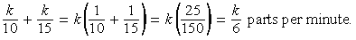 the fraction k over 10, +, the fraction k over 15, which is equal to k times, open parenthesis, one tenth + one fifteenth, close parenthesis, which is equal to k times, open parenthesis, 25 over 150, close parenthesis, which is equal to k over 6 parts per minute. To compute the time required to produce k parts at this rate, divide the amount k by the rate k over 6 to get 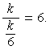 the fraction with numerator k and with denominator k sixths. Therefore, the correct answer is 6 minutes.
One way to check that the answer of 6 minutes is reasonable is to observe that if the slower rate of machine B were the same as machine A’s faster rate of k parts in 10 minutes, then the two machines, working simultaneously, would take half the time, or 5 minutes, to produce the k parts. So the answer has to be greater than 5 minutes. Similarly, if the faster rate of machine A were the same as machine B’s slower rate of k parts in 15 minutes, then the two machines, would take half the time, or 7.5 minutes, to produce the k parts. So the answer has to be less than 7.5 minutes. Thus, the answer of 6 minutes is reasonable compared to the lower estimate of 5 minutes and the upper estimate of 7.5 minutes.

Data Interpretation Sets

Description
Data Interpretation questions are grouped together and refer to the same table, graph, or other data presentation. These questions ask you to interpret or analyze the given data. The types of questions may be Multiple choice (both types) or Numeric Entry.

Tips for Answering
1. Scan the data presentation briefly to see what it is about, but do not spend time studying all of the information in detail. Focus on those aspects of the data that are necessary to answer the questions. Pay attention to the axes and scales of graphs; to the units of measurement or orders of magnitude (such as billions) that are given in the titles, labels, and legends; and to any notes that clarify the data.
2. Bar graphs and circle graphs, as well as other graphical displays of data, are drawn to scale, so you can read or estimate data from such graphs. For example, you can use the relative sizes of bars or sectors to compare the quantities that they represent, but be aware of broken scales and of bars that do not start at 0.
3. The questions are to be answered only on the basis of the data presented, everyday facts (such as the number of days in a year), and your knowledge of mathematics. Do not make use of specialized information you may recall from other sources about the particular context on which the questions are based unless the information can be derived from the data presented.

Directions: Questions 1 through 3 are based on the data in the following 3 column table. The table shows the percent change in the dollar amount of sales at five retail stores from 2006 to 2008. The headers for the columns are: Column 1, Store; Column 2, Percent Change from 2006 to 2007; Column 3, Percent Change from 2007 to 2008. There are five rows of data in the table.
.
Store | Percent Change  from 2006 to 2007 | Percent Change  from 2007 to 2008
P | +10 | minus 10
Q | minus 20 | +9
R | +5 | +12
S | minus 7 | minus 15
T | +17 | minus 8
Figure 8
1. If the dollar amount of sales at Store P was $800,000 for 2006, what was the dollar amount of sales at that store for 2008 ?
A. $727,200
B. $792,000
C. $800,000
D. $880,000
E. $968,000
Explanation
According to the table in Figure 8, if the dollar amount of sales at Store P was $800,000 for 2006, then it was 10 percent greater for 2007, which is 110 percent of that amount, or $880,000. For 2008 the amount was 90 percent of $880,000, which is $792,000. The correct answer is choice B, $792,000.
Note that an increase of 10 percent for one year and a decrease of 10 percent for the following year does not result in the same dollar amount as the original dollar amount because the base that is used in computing the percents is $800,000 for the first change but $880,000 for the second change.
2. At Store T, the dollar amount of sales for 2007 was what percent of the dollar amount of sales for 2008 ?
Give your answer to the nearest 0.1 percent.
% The answer space consists of a box for the answer followed by the % symbol.
Explanation
If A is the dollar amount of sales at Store T for 2007, then 8 percent of A, or is the amount of decrease from 2007 to 2008. Thus A minus 0.08A = 0.92A is the dollar amount for 2008. Therefore, the desired percent can be obtained by dividing A by 0.92A, which equals 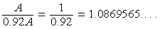 the fraction A over 0.92A, which equals 1 over 0.92, which equals 1.0869565... . Expressed as a percent and rounded to the nearest 0.1 percent, this number is 108.7%. Thus, the correct answer is 108.7% (or equivalent).
3. Which of the following statements must be true?
Indicate all such statements.
A. For 2008 the dollar amount of sales at Store R was greater than that at each of the other four stores.
B. The dollar amount of sales at Store S for 2008 was 22 percent less than that for 2006.
C. The dollar amount of sales at Store R for 2008 was more than 17 percent greater than that for 2006.
Explanation
For choice A, since the only data given in Figure 8 are percent changes from year to year, there is no way to compare the actual dollar amount of sales at the stores for 2008 or for any other year. Even though Store R had the greatest percent increase from 2006 to 2008, its actual dollar amount of sales for 2008 may have been much smaller than that for any of the other four stores, and therefore choice A is not necessarily true.
For choice B, even though the sum of the two percent decreases would suggest a 22 percent decrease, the bases of the percents are different. If B is the dollar amount of sales at Store S for 2006, then the dollar amount for 2007 is 93 percent of B, or and the dollar amount for 2008 is given by 0.85 times 0.93 times B, which is 0.7905B. Note that this represents a percent decrease of 100 minus 79.05 = 20.95 percent, which is less than 22 percent, and so choice B is not true.
For choice C, if C is the dollar amount of sales at Store R for 2006, then the dollar amount for 2007 is given by 1.05C and the dollar amount for 2008 is given by 1.12 times 1.05 C, which is 1.176C. Note that this represents a 17.6 percent increase, which is greater than 17 percent, so choice C must be true.
Therefore, the correct answer consists of only choice C, the dollar amount of sales at Store R for 2008 was more than 17 percent greater than that for 2006.

Using the Calculator
You are allowed to use a basic calculator on the Quantitative Reasoning section of the test. In the standard computer based version of the test, a basic calculator is provided on screen. In other editions of the test, a hand held basic calculator is provided. No other calculator may be used except as an approved accommodation. This section provides general information about using a basic calculator, as well as specific information about using the hand held basic calculator provided. Information about using the on screen calculator provided in the standard computer based edition of the test appears in Appendix B.
Sometimes the computations you need to do to answer a question in the Quantitative Reasoning measure are somewhat tedious or time consuming, like long division or square roots. For such computations, you can use the handheld calculator provided to you at the test site.
Although the calculator can shorten the time it takes to perform computations, keep in mind that the calculator provides results that supplement, but do not replace, your knowledge of mathematics. You must use your mathematical knowledge to determine whether the calculator’s results are reasonable and how the results can be used to answer a question.
Here are five general guidelines for calculator use in the Quantitative Reasoning measure:
1. Most of the questions don’t require difficult computations, so don’t use the calculator just because it’s available.
2. Use it for calculations that you know are tedious, such as long division, square roots, and addition, subtraction, or multiplication of numbers that have several digits.
3. Avoid using it for simple computations that are quicker to do mentally, such as 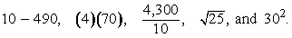 10 minus 490, 4 times 70, 4,300 over 10, the positive square root of 25, and 30 squared.
4. Some questions can be answered more quickly by reasoning and estimating than by using the calculator.
5. If you use the calculator, estimate the answer beforehand so you can determine whether the calculator’s answer is “in the ballpark”. This may help you avoid key entry errors.
The following three guidelines are specific to the handheld calculator provided in editions of the test other than the standard computer based edition:
1. Some computations are not defined for real numbers; for example, division by zero or taking the square root of a negative number. The calculator will indicate that these are errors.
2. The calculator displays up to eight digits. If a computation results in a number larger than 99,999,999, then the calculator will indicate that this is an error. For example, the calculation 10,000,000 times 10 = results in an error.
3. When a computation involves more than one operation, the calculator performs the operations one by one in the order in which they are entered. For example, when the computation 1, +, 2, times, 4 is entered into the calculator, the result is 12. To get this result, the calculator adds 1 and 2, displays a result of 3, and then multiplies 3 and 4 and displays a result of 12. The calculator does not perform operations with respect to the mathematical convention called order of operations, described below.
The order of operations convention, which is purely mathematical and predates calculators, establishes which operations are performed before others in a mathematical expression that has more than one operation. The order is as follows: parentheses, exponentiation (including square roots), multiplications and divisions (from left to right), additions and subtractions (from left to right). For example, the value of the expression 1, +, 2, times, 4 calculated with respect to order of operations is 9, because the expression is evaluated by first multiplying 2 and 4 and then by adding 1 to the result.
Some calculators perform multiple operations using the order of operations convention, but the handheld calculator on the Quantitative Reasoning measure does not; again, it performs multiple operations one by one in the order that they are entered into the calculator.
Below is an example of a computation using the handheld calculator.
1. Compute 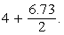 4 plus the fraction 6.73 over 2.
Explanation
Perform the division first; that is, enter 6.73, divided by, 2, = to get 3.365, and then enter +, 4, = to get 7.365. Note that if you enter 4, + 6.73, divided by 2, =, the answer will be incorrect, because the calculator would perform the addition before the division, resulting in 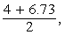 the fraction with numerator 4 + 6.73 and denominator 2, rather than 4 + the fraction 6.73 over 2.

Appendix A. Numeric Entry Directions on the Standard Computer Based Edition
Directions: Enter your answer as an integer or a decimal if there is a single answer box OR as a fraction if there are two separate boxes—one for the numerator and one for the denominator.
To enter an integer or a decimal, either type the number in the answer box using the keyboard or use the Transfer Display button on the calculator.
- First, click on the answer box, a cursor will appear in the box, and then type the number.
- To erase a number, use the Backspace key.
- For a negative sign, type a hyphen. For a decimal point, type a period.
- To remove a negative sign, type the hyphen again and it will disappear; the number will remain.
- The Transfer Display button on the calculator will transfer the calculator display to the answer box.
- Equivalent forms of the correct answer, such as 2.5 and 2.50, are all correct.
- Enter the exact answer unless the question asks you to round your answer.
To enter a fraction, type the numerator and the denominator in the respective boxes using the keyboard.
- For a negative sign, type a hyphen. A decimal point cannot be used in the fraction.
- The Transfer Display button on the calculator cannot be used for a fraction.
- Fractions do not need to be reduced to lowest terms, though you may need to reduce your fraction to fit in the boxes.

Appendix B. Using the Calculator Provided in the Standard Computer Based Edition of the Test
You are allowed to use a basic calculator on the Quantitative Reasoning measure of the test. In the standard computer based version of the test, a basic calculator is provided on screen. In other editions of the test, a hand held basic calculator is provided. No other calculator may be used except as an approved accommodation. Information about using the on screen calculator is provided in this appendix.
The on screen calculator provided in the standard computer based edition of the test is shown in Figure 9.
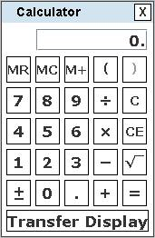
Figure 9

Begin skippable figure description.
The calculator has buttons to enter and perform basic operations on decimal numbers. It also has parentheses, memory buttons, and a “Transfer Display” button.

End skippable figure description.
The following seven guidelines are specific to the on screen calculator:
1. When you use the computer mouse or the keyboard to operate the calculator, take care not to miskey a number or operation.
2 Note all of the calculator’s buttons, including Transfer Display.
3. The Transfer Display button can be used on Numeric Entry questions with a single answer box. This button will transfer the calculator display to the answer box. You should check that the transferred number has the correct form to answer the question. For example, if a question requires you to round your answer or convert your answer to a percent, make sure that you adjust the transferred number accordingly.
4. Take note that the calculator respects order of operations, as explained below.
The order of operations convention, which is purely mathematical and predates calculators, establishes which operations are performed before others in a mathematical expression that has more than one operation. The order is as follows: parentheses, exponentiation (including square roots), multiplications and divisions (from left to right), additions and subtractions (from left to right). With respect to order of operations, the value of the expression 1, +, 2, times 4 is 9 because the expression is evaluated by first multiplying 2 and 4 and then by adding 1 to the result. This is how the calculator in the Quantitative Reasoning measure performs the operations.
5. In addition to parentheses, the on-screen calculator has one memory location and three memory buttons that govern it: memory recall MR, memory clear MC, and memory sum M+. These buttons function as they normally do on most basic calculators.
6. Some computations are not defined for real numbers; for example, division by zero or taking the square root of a negative number. If you enter 6, divided by, 0, =, the word Error will be displayed. Similarly, if you enter 1, plus/minus, positive square root, then Error will be displayed. To clear the display, you must press the clear button C.
7. The calculator displays up to eight digits. If a computation results in a number larger than 99,999,999, then Error will be displayed. For example, the calculation 10,000,000, times, 10, = results in Error. The clear button C must be used to clear the display.
Below are six examples of computations using the calculator.
Example 1. Compute 4 plus the fraction 6.73 over 2.
Explanation
Enter 4, +, 6.73, divided by, 2, = to get 7.365. Alternatively, enter 6.73, divided by, 2, = to get 3.365, and then enter +, 4, = to get 7.365.
Example 2. Compute 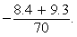 the negative of the fraction with numerator 8.4 + 9.3, and denominator 70.
Explanation
Since division takes precedence over addition in the order of operations, you need to override that precedence in order to compute this fraction. Here are two ways to do that. You can use the parentheses for the addition in the numerator, entering open parenthesis, 8.4, +, 9.3, close parenthesis, divided by, 70, =, plus/minus to get negative 0.2528571. Or you can use the equals sign after 9.3, entering 8.4, +, 9.3, =, divided by, 70, =, plus/minus to get the same result. In the second way, note that pressing the first = is essential, because without it, 8.4, +, 9.3, divided by, 70, =, plus/minus would erroneously compute 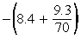 negative, open parenthesis, 8.4, + the fraction 9.3 over 70, close parenthesis instead. Incidentally, the exact result of the computation is the repeating decimal negative 0.25285714 with a bar over the 6 digits 2 8 5 7 1 4. (The bar over the digits 2 8 5 7 1 4 indicates that they repeat without ending). The calculator rounds the repeating decimal to negative 0.2528571.
Example 3. Find the length, to the nearest 0.01, of the hypotenuse of a right triangle with legs of length 21 and 54; that is, use the Pythagorean theorem to calculate the positive square root of the quantity, 21 squared plus 54 squared.
Explanation
Enter 21, times, 21, +, 54, times, 54, =, positive square root to get 57.939624. Again, pressing the = before the positive square root is essential because 21, times, 21, +, 54, times, 54, positive square root, = would erroneously compute 21 squared + 54 times the square root of 54. This is because the square root would take precedence over the division in the order of operations. Note that parentheses could be used, as in open parenthesis, 21, times, 21, close parenthesis, +, open parenthesis, 54, times, 54, close parenthesis, =, positive square root but they are not necessary because the multiplications already takes precedence over the addition. Incidentally, the exact answer is a nonterminating, nonrepeating decimal, or an irrational number, but the calculator rounds the decimal to 57.939624. Finally, note that the problem asks for the answer to the nearest 0.01, so the correct answer is 57.94.
Example 4. Compute open parenthesis, negative 15, close parenthesis, cubed.
Explanation
Enter 15, plus/minus, times, 15, plus/minus, times 15, plus/minus, = to get negative 3,375.
Example 5. Convert 6 miles per hour to feet per second.
Explanation
The solution to this problem uses the conversion factors 1 mile = 5,280 feet and 1 hour = 3,600 seconds as follows:
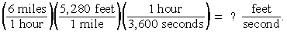
open parenthesis, 6 miles over 1 hour, close parenthesis, times, 5,280 feet over 1 mile, times, 1 hour over 3,600 seconds, close parenthesis, = question, feet over second.
Enter 6, times, 5,280, divided by, 3,600, = to get 8.8. Alternatively, enter 6, times, 5,280, = to get the result 31,680, and then enter divided by, 3,600, = to get 8.8 feet per second.
Example 6. At a fund-raising event, 43 participants donated $60 each, 21 participants donated $80 each, and 16 participants donated $100 each. What was the average (arithmetic mean) donation per participant, in dollars?
Explanation
The solution to this problem is to compute the weighted mean 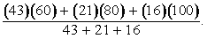 the fraction with numerator equal to the quantity 43 times 60, +, 21 times 80, +, 16 times 100, and denominator equal to the quantity 43 + 21 + 16. In using the calculator to compute the weighted mean, it is useful to take advantage of the calculator’s memory buttons and parenthesis.
To do this calculation using the calculator’s memory buttons note the following:
1. To enter a number into memory, make sure the memory is clear then enter the number followed by the memory sum button.
2. To add a number, n, to a number that is stored in memory, t, enter the number, n, followed by the memory sum button. At the end of this computation the number n will appear in the display, and the number n + t will be stored in memory. To retrieve the number n + t from memory, use the memory recall button.
To compute the weighted mean first calculate the value of the numerator and store it in memory as follows:
43, times, 60, =, memory sum, 21, times, 80, =, memory sum, 16, times, 100, = memory sum.
Then retrieve the numerator from memory and divide by the denominator as follows: (Note that you need to put parenthesis around the sum in the denominator.)
memory recall, divided by, open parenthesis, 43, +, 21 +, 16, close parenthesis, =.
The result is 73.25, or $73.25 per participant.
When the memory recall button is pressed in the computation above, the current value in memory, 5,860, is displayed. To clear the memory, use the memory clear button, and the M next to the display disappears.

