General Problem-Solving Steps
Questions in the Quantitative Reasoning measure ask you to model and solve problems using quantitative, or mathematical, methods. Generally, there are three basic steps in solving a mathematics problem:
Step 1: Understand the problem
Step 2: Carry out a strategy for solving the problem
Step 3: Check your answer
Here is a description of the three steps, followed by a list of useful strategies for solving mathematics problems.

Step 1: Understand the Problem
The first step is to read the statement of the problem carefully to make sure you understand the information given and the problem you are being asked to solve.
Some information may describe certain quantities. Quantitative information may be given in words or mathematical expressions, or a combination of both. Also, in some problems you may need to read and understand quantitative information in data presentations, geometric figures, or coordinate systems. Other information may take the form of formulas, definitions, or conditions that must be satisfied by the quantities. For example, the conditions may be equations or inequalities, or may be words that can be translated into equations or inequalities.
In addition to understanding the information you are given, it is important to understand what you need to accomplish in order to solve the problem. For example, what unknown quantities must be found? In what form must they be expressed?

Step 2: Carry Out a Strategy for Solving the Problem
Solving a mathematics problem requires more than understanding a description of the problem, that is, more than understanding the quantities, the data, the conditions, the unknowns, and all other mathematical facts related to the problem. It requires determining what mathematical facts to use and when and how to use those facts to develop a solution to the problem. It requires a strategy.
Mathematics problems are solved by using a wide variety of strategies. Also, there may be different ways to solve a given problem. Therefore, you should develop a repertoire of problem-solving strategies, as well as a sense of which strategies are likely to work best in solving particular problems. Attempting to solve a problem without a strategy may lead to a lot of work without producing a correct solution.
After you determine a strategy, you must carry it out. If you get stuck, check your work to see if you made an error in your solution. It is important to have a flexible, open mind-set. If you check your solution and cannot find an error or if your solution strategy is simply not working, look for a different strategy.

Step 3: Check Your Answer
When you arrive at an answer, you should check that it is reasonable and computationally correct.
- Have you answered the question that was asked?
- Is your answer reasonable in the context of the question? Checking that an answer is reasonable can be as simple as recalling a basic mathematical fact and checking whether your answer is consistent with that fact. For example, the probability of an event must be between 0 and 1, inclusive, and the area of a geometric figure must be positive. In other cases, you can use estimation to check that your answer is reasonable. For example, if your solution involves adding three numbers, each of which is between 100 and 200, estimating the sum tells you that the sum must be between 300 and 600.
- Did you make a computational mistake in arriving at your answer? A key-entry error using the calculator? You can check for errors in each step in your solution. Or you may be able to check directly that your solution is correct. For example, if you solved the equation 7 times, open parenthesis, 3 x minus 2, close parenthesis, + 4, = 95 for x and got the answer x = 5, you can check your answer by substituting x = 5 into the equation to see that 7 times, open parenthesis, 3 times 5, minus 2, close parenthesis, + 4, = 95.

Strategies
There are no set rules—applicable to all mathematics problems—to determine the best strategy. The ability to determine a strategy that will work grows as you solve more and more problems. What follows are brief descriptions of useful strategies. Along with each strategy one or two sample questions that you can answer with the help of the strategy are given. These strategies do not form a complete list, and, aside from grouping the first four strategies together, they are not presented in any particular order.
The first four strategies are translation strategies, where one representation of a mathematics problem is translated into another.

Strategy 1: Translate from Words to an Arithmetic or Algebraic Representation
Word problems are often solved by translating textual information into an arithmetic or algebraic representation. For example, an “odd integer” can be represented by the expression 2n +1, where n is an integer; and the statement “the cost of a taxi trip is $3.00, plus $1.25 for each mile” can be represented by the expression c = 3 + 1.25m. More generally, translation occurs when you understand a word problem in mathematical terms in order to model the problem mathematically.

Sample Question 1 for Strategy 1: Multiple-Choice – Select One Answer Choice Question.
A car got 33 miles per gallon using gasoline that cost $2.95 per gallon. Approximately what was the cost, in dollars, of the gasoline used in driving the car 350 miles?
- $10
- $20
- $30
- $40
- $50

Explanation
Scanning the answer choices indicates that you can do at least some estimation and still answer confidently. The car used 350 over 33 gallons of gasoline, so the cost was open parenthesis, 350 over 33, close parenthesis, times 2.95 dollars. You can estimate the product open parenthesis, 350 over 33, close parenthesis, times 2.95 by estimating 350 over 33 a little low, 10, and estimating 2.95 a little high, 3, to get approximately 10 times 3 = 30 dollars. You can also use the calculator to compute a more exact answer and then round the answer to the nearest 10 dollars, as suggested by the answer choices. The calculator yields the decimal 31.287…, which rounds to 30 dollars. Thus, the correct answer is Choice C, $30.

Sample Question 2 for Strategy 1: Numeric Entry Question.
Working alone at its constant rate, machine A produces k liters of a chemical in 10 minutes. Working alone at its constant rate, machine B produces k liters of the chemical in 15 minutes. How many minutes does it take machines A and B, working simultaneously at their respective constant rates, to produce k liters of the chemical?
The answer space for this question is followed by the word minutes.

Explanation
Machine A produces k over 10 liters per minute, and machine B produces k over 15 liters per minute. So when the machines work simultaneously, the rate at which the chemical is produced is the sum of these two rates, which is the fraction k over 10, +, the fraction k over 15, which is equal to k times, open parenthesis, one tenth + one fifteenth, close parenthesis, which is equal to k times, open parenthesis, 25 over 150, close parenthesis, which is equal to k over 6 liters per minute. To compute the time required to produce k liters at this rate, divide the amount k by the rate k over 6 to get the fraction with numerator k and with denominator k sixths = 6. Therefore, the correct answer is 6 minutes (or equivalent).
One way to check that the answer of 6 minutes is reasonable is to observe that if the slower rate of machine B were the same as machine A’s faster rate of k liters in 10 minutes, then the two machines, working simultaneously, would take half the time, or 5 minutes, to produce the k liters. So the answer has to be greater than 5 minutes. Similarly, if the faster rate of machine A were the same as machine B’s slower rate of k liters in 15 minutes, then the two machines would take half the time, or 7.5 minutes, to produce the k liters. So the answer has to be less than 7.5 minutes. Thus, the answer of 6 minutes is reasonable compared to the lower estimate of 5 minutes and the upper estimate of 7.5 minutes.

Strategy 2: Translate from Words to a Figure or Diagram
To solve a problem in which a figure is described but not shown, draw your own figure. Draw the figure as accurately as possible, labeling as many parts as possible, including any unknowns.
Drawing figures can help in geometry problems as well as in other types of problems. For example, in probability and counting problems, drawing a diagram can sometimes make it easier to analyze the relevant data and to notice relationships and dependencies.

Sample Question for Strategy 2: Multiple-Choice – Select One Answer Choice Question.
Which of the following numbers is farthest from the number 1 on the number line?
A. negative 10
B. negative 5
C. 0
D. 5
E. 10

Explanation
Circling each of the answer choices in a sketch of the following number line shows that of the given numbers, negative 10 is the greatest distance from 1.
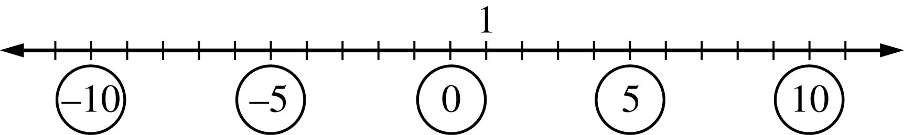

Begin figure description.
The figure is a number line with 23 equally spaced tick marks labeled with the integers from negative 11 through positive 11. Going from left to right, the 5 evenly spaced integers negative 10, negative 5, 0, 5, and 10 are circled. The integer 1 is 1 tick mark to the right of 0.

End figure description.
Another way to answer the question is to remember that the distance between two numbers on the number line is equal to the absolute value of the difference of the two numbers. For example, the distance between negative 10 and 1 is the absolute value of negative 10 minus 1, which equals 11 and the distance between 10 and 1 is the absolute value of 10 minus 1, which equals the absolute value of 9, which equals 9. The correct answer is Choice A, . negative 10.

Strategy 3: Translate from an Algebraic to a Graphical Representation
Many algebra problems can be represented graphically in a coordinate system, whether the system is a number line if the problem involves one variable, or a coordinate plane if the problem involves two variables. Such graphs can clarify relationships that may be less obvious in algebraic presentations.

Sample Question for Strategy 3: Multiple-Choice – Select One Answer Choice Question.
This question is based on the following figure.
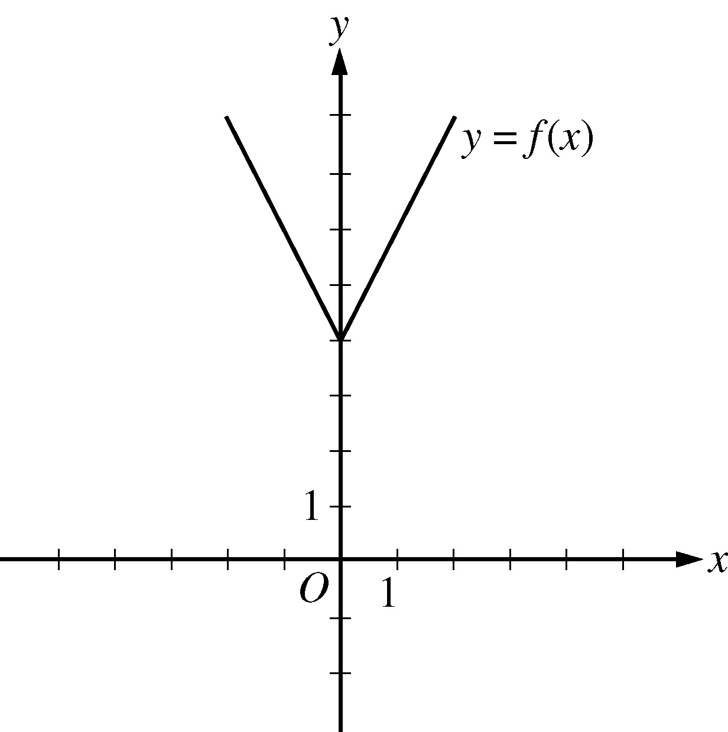

Begin figure description.
The figure shows the graph in the xy-plane of the function f of x = the absolute value of 2x, end absolute value, + 4. There are equally spaced tick marks along the x-axis and along the y-axis. The first tick mark to the right of the origin, and the first tick mark above the origin, are both labeled 1.
The graph of the function f is in the shape of the letter V. It is above the x-axis and is symmetric with respect to the y-axis.
The lowest point on the graph of f is the point 0 comma 4, which is located on the y-axis at the fourth tick mark above the origin.
Going leftward from the point 0 comma 4, the graph of f is a line that slants upward, passing through the point negative 2 comma 8.
Going rightward from the point 0 comma 4, the graph of f is a line that slants upward, passing through the point 2 comma 8.

End figure description.
The figure shows the graph of the function f, defined by , f of x = the absolute value of 2 x, end absolute value, + 4 for all numbers x. For which of the following functions g, defined for all numbers x, does the graph of g intersect the graph of f ?
- g of x = x minus 2
- g of x = x + 3
- g of x = 2 x minus 2
- g of x = 2 x + 3
- g of x = 3 x minus 2

Explanation
You can see that all five choices are linear functions whose graphs are lines with various slopes and y-intercepts. The graph of Choice A is a line with slope 1 and y-intercept negative 2 shown in the following figure.
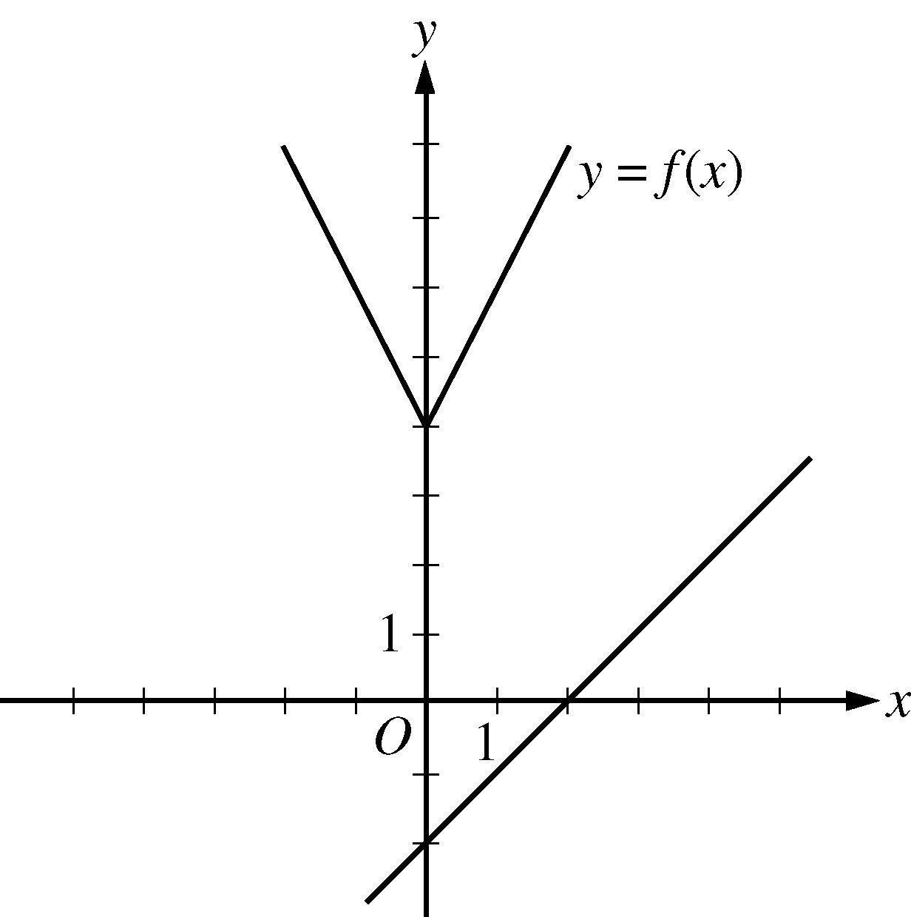

Begin figure description.
This figure is the same as the figure accompanying the question except that the graph of the line with slope 1 and y-intercept negative 2 has been added. The line slants upward as you go from left to right and intersects the x-axis at 2. The line is below the graph of y equals f of x.

End figure description.
It is clear that this line will not intersect the graph of f to the left of the y-axis. To the right of the y-axis, the graph of f is a line with slope 2, which is greater than slope 1. Consequently, as the value of x increases, the value of y increases faster for f than for g, and therefore the graphs do not intersect to the right of the y-axis. Choice B is similarly ruled out. Note that if the y-intercept of either of the lines in choices A and B were greater than or equal to 4 instead of less than 4, they would intersect the graph of f.
Choices C and D are lines with slope 2 and y-intercepts less than 4. Hence, they are parallel to the graph of f (to the right of the y-axis) and therefore will not intersect it. Any line with a slope greater than 2 and a y-intercept less than 4, like the line in Choice E, will intersect the graph of f (to the right of the y-axis). The correct answer is Choice E, . g of x = 3 x minus 2.
Note: This question also appears as a sample question for Strategy 6.

Strategy 4: Translate from a Figure to an Arithmetic or Algebraic Representation
When a figure is given in a problem, it may be effective to express relationships among the various parts of the figure using arithmetic or algebra.

Sample Question 1 for Strategy 4: Quantitative Comparison Question.
This question is based on the following figure.
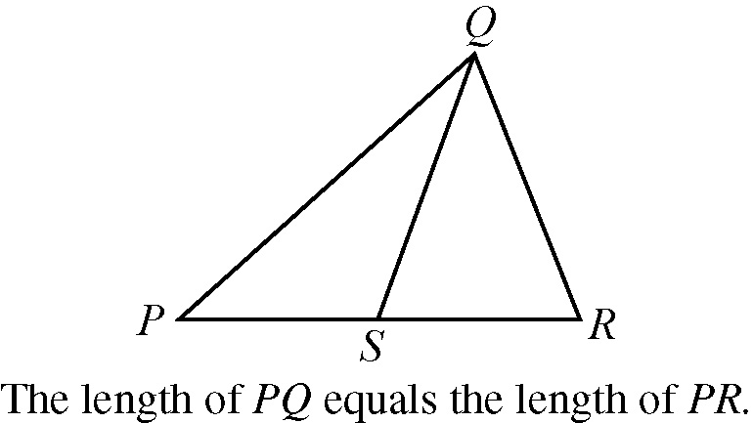

Begin figure description.
The figure shows triangle PQR, where P is the leftmost vertex of the horizontal side PR and vertex Q is above PR. Point S lies on horizontal side PR. Point S appears to be the midpoint of PR. Line segment QS is drawn from vertex Q to point S. The lengths of PS and SR appear to be equal.
It is given that the length of PQ is equal to the length of PR.

End figure description.
Quantity A: The length of PS
Quantity B: The length of SR
- Quantity A is greater.
- Quantity B is greater.
- The two quantities are equal.
- The relationship cannot be determined from the information given.

Explanation
From the figure accompanying the question, you know that PQR is a triangle and that point S is between points P and R, so the length of P S is less than the length of P R and the length of SR is less than the length of P R. You are also given that the length of P Q is equal to the length of P R. However, this information is not sufficient to compare the length of P S and the length of S R. Furthermore, because the figure is not necessarily drawn to scale, you cannot determine the relative sizes of the length of P S and the length of S R visually from the figure, though they may appear to be equal. The position of S can vary along side P R anywhere between P and R. Below are two possible variations of the figure accompanying the question, each of which is drawn to be consistent with the information that the length of P Q is equal to the length of P R.

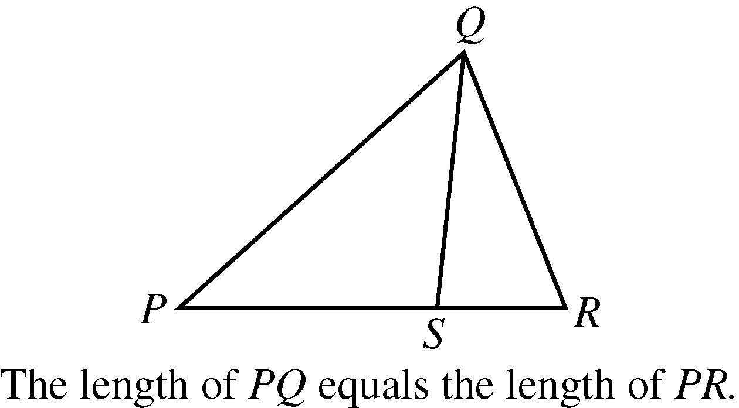
Variation 1

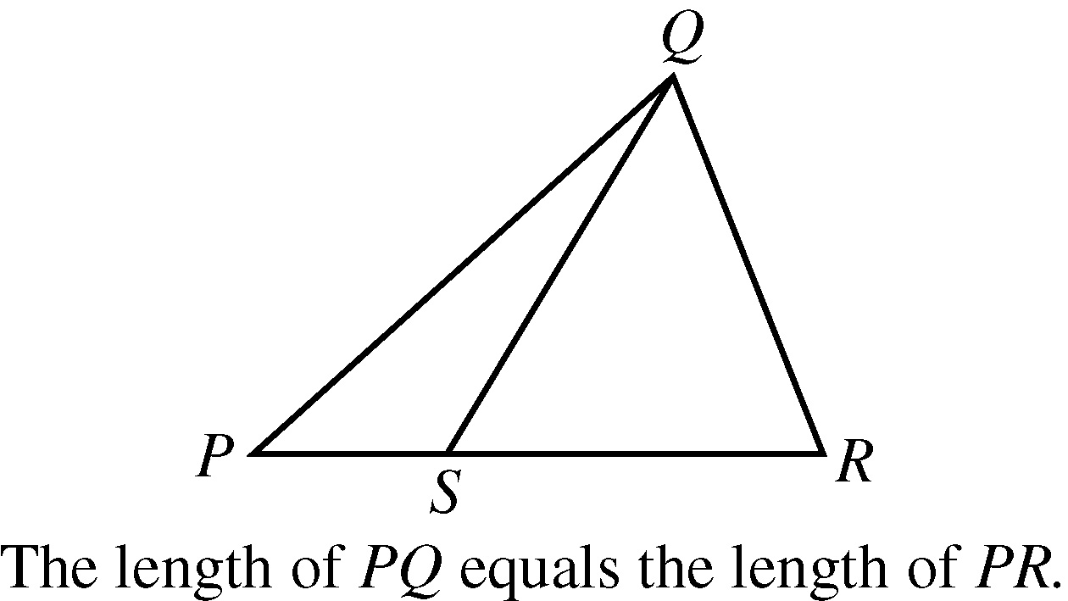
Variation 2

Begin figure description.
In variation 1, instead of appearing to be the midpoint of PR, S appears to be closer to R than to P and the length of PS appears to be greater than the length of SR.
In variation 2, instead of appearing to be the midpoint of PR, S appears to be closer to P than to R and the length of PS appears to be less than the length of SR.

End figure description.
Note that in the previous figures, Quantity A, the length of PS, is greater in Variation 1 and Quantity B, the length of SR, is greater in Variation 2. Thus, the correct answer is Choice D, the relationship cannot be determined from the information given.

Sample Question 2 for Strategy 4: Numeric Entry Question.
This question is based on the following 3-column table, which summarizes the results of a used-car auction. The first row of the table contains column headers. The header for the second column is “Small Cars” and the header for the third column is “Large Cars”. There is no header for the first column. There are 4 rows of data in the table.
Results of a Used-Car Auction
 | Small Cars | Large Cars
Number of cars offered | 32 | 23
Number of cars sold | 16 | 20
Projected sales total for cars offered (in thousands) | $70 | $150
Actual sales total (in thousands) | $41 | $120
For the large cars sold at an auction that is summarized in the table, what was the average sale price per car?
The answer space for this question is preceded by a dollar sign.

Explanation
From the table accompanying the question, you see that the number of large cars sold was 20 and the sales total for large cars was $120,000 (not $120). Thus the average sale price per car was $120,000 over 20 = $6,000. The correct answer is $6,000 (or equivalent).

Strategy 5: Simplify an Arithmetic or Algebraic Representation
Arithmetic and algebraic representations include both expressions and equations. Your facility in simplifying a representation can often lead to a quick solution. Examples include converting from a percent to a decimal, converting from one measurement unit to another, combining like terms in an algebraic expression, and simplifying an equation until its solutions are evident.

Sample Question 1 for Strategy 5: Quantitative Comparison Question.
It is given that y is greater than 4.
Quantity A: the fraction with numerator 3y + 2, and denominator 5
Quantity B: y
- Quantity A is greater.
- Quantity B is greater.
- The two quantities are equal.
- The relationship cannot be determined from the information given.

Explanation
Set up the initial comparison of Quantity A and Quantity B using a placeholder question mark symbol as follows:
the fraction with numerator 3y + 2 and denominator 5, followed by a question mark symbol, followed by y.
Then simplify:
Step 1: Multiply both sides by 5 to get 3y + 2, followed by the question mark symbol, followed by 5y.
Step 2: Subtract 3y from both sides to get 2, followed by the question mark symbol, followed by 2 y.
Step 3: Divide both sides by 2 to get 1, followed by the question mark symbol, followed by y.
The comparison is now simplified as much as possible. In order to compare 1 and y, note that along with Quantities A and B you are given the additional information y is greater than 4. It follows from y is greater than 4 that y is greater than 1 or 1 is less than y, so that in the comparison 1, followed by the question mark symbol, followed by y, the placeholder represents less than : 1 is less than y.
However, the problem asks for a comparison between Quantity A and Quantity B, not a comparison between 1 and y. To go from the comparison between 1 and y to a comparison between Quantities A and B, start with the last comparison, 1 is less than y, and carefully consider each simplification step in reverse order to determine what each comparison implies about the preceding comparison, all the way back to the comparison between Quantities A and B if possible. Since step 3 was “divide both sides by 2,” multiplying both sides of the comparison 1 is less than y, by 2 implies the preceding comparison 2 is less than 2y, thus reversing step 3. Each simplification step can be reversed as follows:
Step 3 was “Divide both sides by 2.” To reverse this step, you need to multiply both sides by 2. The result of reversing step 3 is 2 is less than 2y.
Step 2 was “Subtract 3y from both sides.” To reverse the step you need to add 3y to both sides. The result of reversing step 2 is 3y + 2 is less than 5y.
Step 1 was “Multiply both sides by 5.” To reverse this step, divide both sides by 5. The result of reversing step 1 is 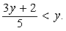 the fraction with numerator 3y + 2 and denominator 5 is less than y.
When each step is reversed, the relationship remains less than , so Quantity A is less than Quantity B. Thus, the correct answer is Choice B, Quantity B is greater.

Sample Question 2 for Strategy 5: Numeric Entry Question.
A merchant made a profit of $5 on the sale of a sweater that cost the merchant $15. What is the profit expressed as a percent of the merchant’s cost?
Give your answer to the nearest whole percent.
The answer space for this question is followed by a % sign.

Explanation
The percent profit is open parenthesis, 5 over 15, close parenthesis, times 100, which equals 33.333..., which equals 33 point 3 with a bar over it, percent, which is 33%, to the nearest whole percent. Thus, the correct answer is 33% (or equivalent).
If you are taking the standard computer-based version of the test, and you use the calculator and the Transfer Display button, the number that will be transferred to the answer box is 33.333333, which is incorrect since it is not given to the nearest whole percent. You will need to adjust the number in the answer box by deleting all of the digits to the right of the decimal point (using the Backspace key).
Also, since you are asked to give the answer as a percent, the decimal equivalent of 33 percent, which is 0.33, is incorrect. The percent symbol next to the answer box indicates that the form of the answer must be a percent. Entering 0.33 in the box would give the erroneous answer 0.33%.

Strategy 6: Add to a Geometric Figure
Sometimes you can add useful lines, points, or circles to a geometric figure to facilitate solving a problem. You can also add any given information—as well as any new information as you derive it—to the figure to help you see relationships within the figure more easily, for example, the length of a line segment or the measure of an angle.

Sample Question 1 for Strategy 6: Multiple-Choice – Select One Answer Choice Question.

Begin figure description.
The figure shows the graph in the xy-plane of the function f of x equals the absolute value of 2x, end absolute value, + 4. There are equally spaced tick marks along the x-axis and along the y-axis. The first tick mark to the right of the origin, and the first tick mark above the origin, are both labeled 1.
The graph of the function f is in the shape of the letter V. It is above the x-axis and is symmetric with respect to the y-axis.
The lowest point on the graph of f is the point 0 comma 4, which is located on the y-axis at the fourth tick mark above the origin.
Going leftward from the point 0 comma 4, the graph of f is a line that slants upward, passing through the point negative 2 comma 8. Going rightward from the point 0 comma 4, the graph of f is a line that slants upward, passing through the point 2 comma 8.

End figure description.
The figure shows the graph of the function f, defined by , f of x equals the absolute value of 2 x, end absolute value, plus 4 for all numbers x. For which of the following functions g, defined for all numbers x, does the graph of g intersect the graph of f ?
A. g of x = x minus 2
B. g of x = x + 3
C. g of x = 2 x minus 2
D. g of x = 2 x + 3
E. g of x = 3 x minus 2

Explanation
You can see that all five choices are linear functions whose graphs are lines with various slopes and y-intercepts. The graph of Choice A is a line with slope 1 and y-intercept negative 2 shown in the following figure.

Begin Figure Description
This figure is the same as the figure accompanying the question except that the graph of the line with slope 1 and y-intercept negative 2 has been added. The line slants upward as you go from left to right and intersects the x-axis at 2. The line is below the graph of y equals f of x.

End figure description.
It is clear that this line will not intersect the graph of f to the left of the y-axis. To the right of the y-axis, the graph of f is a line with slope 2, which is greater than slope 1. Consequently, as the value of x increases, the value of y increases faster for f than for g, and therefore the graphs do not intersect to the right of the y-axis. Choice B is similarly ruled out. Note that if the y-intercept of either of the lines in choices A and B were greater than or equal to 4 instead of less than 4, they would intersect the graph of f.
Choices C and D are lines with slope 2 and y-intercepts less than 4. Hence, they are parallel to the graph of f (to the right of the y-axis) and therefore will not intersect it. Any line with a slope greater than 2 and a y-intercept less than 4, like the line in Choice E, will intersect the graph of f (to the right of the y-axis). The correct answer is Choice E, . g of x = 3 x minus 2.
Note: This question also appears as a sample question for Strategy 3.

Strategy 7: Find a Pattern
Patterns are found throughout mathematics. Identifying a pattern is often the first step in understanding a complex mathematical situation. Pattern recognition yields insight that may point in the direction of a complete solution to the problem or simply help you generate a hypothesis, which requires further exploration using another strategy. In a problem where you suspect there is a pattern but don’t recognize it yet, working with particular instances can help you identify the pattern. Once a pattern is identified, it can be used to answer questions.

Sample Question for Strategy 7: Multiple-Choice – Select One or More Answer Choices Question.
Which of the following could be the units digit of 57 to the power n, where n is a positive integer?
Indicate all such digits.
- 0
- 1
- 2
- 3
- 4
- 5
- 6
- 7
- 8
- 9

Explanation
The units digit of 57 to the power n is the same as the units digit of 7 to the power n for all positive integers n. To see why this is true for n = 2, compute 57 to the power 2 by hand and observe how its units digit results from the units digit of 7 to the power 2. Because this is true for every positive integer n, you need to consider only powers of 7. Beginning with n = 1 and proceeding consecutively, the units digits of 7, 7 to the power 2, 7 to the power 3, 7 to the power 4, and 7 to the power 5 are 7, 9, 3, 1, and 7, respectively. In this sequence, the first digit, 7, appears again, and the pattern of four digits, 7, 9, 3, 1, repeats without end. Hence, these four digits are the only possible units digits of 7 to the power n and therefore of 57 to the power n. The correct answer consists of the four choices B, D, H, and J, which are 1, 3, 7, and 9, respectively.
Note: This question also appears as a sample question for Strategy 12.

Strategy 8: Search for a Mathematical Relationship
More general than patterns, mathematical relationships exist throughout mathematics. Problems may involve quantities that are related algebraically, sets that are related logically, or figures that are related geometrically. Also, there may be relationships between information given textually, algebraically, graphically, etc. To express relationships between quantities, it is often helpful to introduce one or more variables to represent the quantities. Once a relationship is understood and expressed, it is often the key to solving a problem.

Sample Question 1 for Strategy 8: Quantitative Comparison Question.
Quantity A: x squared, + 1
Quantity B: 2x, minus 1
- Quantity A is greater.
- Quantity B is greater.
- The two quantities are equal.
- The relationship cannot be determined from the information given.

Explanation
Set up the initial comparison of Quantity A and Quantity B:
x squared + 1, followed by a made up question mark symbol, followed by 2x, minus 1.
Then simplify by noting that the quadratic polynomial x squared, minus 2x, + 1 can be factored:
Step 1: Subtract 2x from both sides to get x squared, minus 2x, + 1, followed by the question mark symbol, followed by negative 1.
Step 2: Factor the left hand side to get open parenthesis, x minus 1, close parenthesis, squared, followed by the question mark symbol, followed by negative 1.
The left hand side of the comparison is the square of a number. Since the square of a number is always greater than or equal to 0, and 0 is greater than negative 1, the simplified comparison is the inequality open parenthesis, x minus 1, close parenthesis, squared, is greater than negative 1 and the resulting relationship is greater than (>). In reverse order, each simplification step implies the inequality greater than (>) in the preceding comparison. Therefore, Quantity A is greater than Quantity B. The correct answer is choice A, Quantity A is greater.

Sample Question 2 for Strategy 8: Multiple-Choice – Select One or More Answer Choices Question.
Each employee of a certain company is in either Department X or Department Y, and there are more than twice as many employees in Department X as in Department Y. The average (arithmetic mean) salary is $25,000 for the employees in Department X and $35,000 for the employees in Department Y. Which of the following amounts could be the average salary for all of the employees of the company?
Indicate all such amounts.
- $26,000
- $28,000
- $29,000
- $30,000
- $31,000
- $32,000
- $34,000

Explanation
One strategy for answering this kind of question is to find the least and/or greatest possible value. Clearly the average salary is between $25,000 and $35,000, and all of the answer choices are in this interval. Since you are told that there are more employees with the lower average salary, the average salary of all employees must be less than the average of $25,000 and $35,000, which is $30,000. If there were exactly twice as many employees in Department X as in Department Y, then the average salary for all employees would be, to the nearest dollar, the following weighted mean, the fraction with numerator 2 times 25,000, +, 1 times 35,000, and denominator 2 + 1, which is approximately 28,333 dollars, where the weight for $25,000 is 2 and the weight for $35,000 is 1. Since there are more than twice as many employees in Department X as in Department Y, the actual average salary must be even closer to $25,000 because the weight for $25,000 is greater than 2. This means that $28,333 is the greatest possible average. Among the choices given, the possible values of the average are therefore $26,000 and $28,000. Thus, the correct answer consists of Choices A ($26,000) and B ($28,000).
Intuitively, you might expect that any amount between $25,000 and $28,333 is a possible value of the average salary. To see that $26,000 is possible, in the weighted mean above, use the respective weights 9 and 1 instead of 2 and 1. To see that $28,000 is possible, use the respective weights 7 and 3.
Note: This question also appears as a sample question for Strategy 12.

Strategy 9: Estimate
Sometimes it is not necessary to perform extensive calculations to solve a problem—it is sufficient to estimate the answer. The degree of accuracy needed depends on the particular question being asked. Care should be taken to determine how far off your estimate could possibly be from the actual answer to the question. Estimation can also be used to check whether the answer to a question is reasonable.

Sample Question 1 for Strategy 9: Quantitative Comparison Question.
Quantity A: 54% of 360
Quantity B: 150
- Quantity A is greater.
- Quantity B is greater.
- The two quantities are equal.
- The relationship cannot be determined from the information given.

Explanation
This question asks you to compare Quantity A: 54% of 360, and Quantity B: 150.
Without doing the exact computation, you can see that 54 percent of 360 is greater than one half of 360, which is 180, and 180 is greater than Quantity B, 150. Thus, the correct answer is Choice A, Quantity A is greater.

Sample Question 2 for Strategy 9: Multiple-Choice – Select One Answer Choice Question.
A car got 33 miles per gallon using gasoline that cost $2.95 per gallon. Approximately what was the cost, in dollars, of the gasoline used in driving the car 350 miles?
- $10
- $20
- $30
- $40
- $50

Explanation
Scanning the answer choices indicates that you can do at least some estimation and still answer confidently. The car used 350 over 33, gallons of gasoline, so the cost was open parenthesis, 350 over 33, close parenthesis, times 2.95 dollars. You can estimate the product open parenthesis, 350 over 33, close parenthesis, times 2.95 by estimating 350 over 33 a little low, 10, and estimating 2.95 a little high, 3, to get approximately 10 times 3 = 30 dollars.
You can also use the calculator to compute a more exact answer and then round the answer to the nearest 10 dollars, as suggested by the answer choices. The calculator yields the decimal 31.287…, which rounds to 30 dollars. Thus, the correct answer is Choice C, $30.

Strategy 10: Trial and Error

Version 1: Make a Reasonable Guess and then Refine It
For some problems, the fastest way to a solution is to make a reasonable guess at the answer, check it, and then improve on your guess. This is especially useful if the number of possible answers is limited. In other problems, this approach may help you at least to understand better what is going on in the problem.

Sample Question for Strategy 10, Version 1: Multiple-Choice – Select One or More Answer Choice Question.
Which two of the following numbers have a product that is between negative 1 and 0?
Indicate both of the numbers.
- negative 20
- negative 10
- 2 to the negative 4 power
- 3 to the negative 2 power

Explanation
For this question, you must select a pair of answer choices. The product of the pair must be negative, so the possible products are the product negative 20, times 2 to the negative 4 power, the product negative 20, times three to the negative 2 power, the product negative 10, times 2 to the negative 4 power, and, the product negative 10, times 3 to the negative 2 power. The product must also be greater than –1. negative 1. The first product is the fraction negative 20, over 2 to the fourth power, which is equal to the negative of the fraction 20 over 16, which is less than negative 1. the second product is the fraction negative 20, over 3 to the second power, which is equal to the negative of the fraction 20 over 9, which is less than negative 1. and the third product is, the fraction negative 10, over 2 to the fourth power, which is equal to the negative of the fraction 10 over 16, which is greater than negative 1, so you can stop there. The correct answer consists of Choices B (–10) negative 10 and C (2^{–4}). 2 to the negative 4 power.

Version 2: Try More Than One Value of a Variable
To explore problems containing variables, it is useful to substitute values for the variables. It often helps to substitute more than one value for each variable. How many values to choose and what values are good choices depends on the problem. Also dependent on the problem is whether this approach, by itself, will yield a solution or whether the approach will simply help you generate a hypothesis that requires further exploration using another strategy.

Sample Question 1 for Strategy 10, Version 2: Quantitative Comparison Question.
Lionel is younger than Maria.
Quantity A: Twice Lionel’s age
Quantity B: Maria’s age
- Quantity A is greater.
- Quantity B is greater.
- The two quantities are equal.
- The relationship cannot be determined from the information given.

Explanation
If Lionel’s age is 6 years and Maria’s age is 10 years, then Quantity A is greater, but if Lionel’s age is 4 years and Maria’s age is 10 years, then Quantity B is greater. Thus, the relationship cannot be determined. The correct answer is Choice D, the relationship cannot be determined from the information given.

Sample Question 2 for Strategy 10, Version 2: Quantitative Comparison Question.
y = 2 times the square of x, plus 7x, minus 3
Quantity A: x
Quantity B: y
- Quantity A is greater.
- Quantity B is greater.
- The two quantities are equal.
- The relationship cannot be determined from the information given.

Explanation
If x = 0, then y = 2 times, open parenthesis, 0 squared close parenthesis, +,7 times open parenthesis, 0, close parenthesis, minus 3, which is equal to negative 3, so in this case, x is greater than y; but if x = 1, then y = 2 times, open parenthesis, 1 squared, close parenthesis, + 7 times, open parenthesis, 1 close parenthesis, minus 3, which is equal to 6, so in that case, y is greater than x. Thus, the correct answer is Choice D, the relationship cannot be determined from the information given.
Note that plugging numbers into expressions may not be conclusive. However, it is conclusive if you get different results after plugging in different numbers: the conclusion is that the relationship cannot be determined from the information given. It is also conclusive if there are only a small number of possible numbers to plug in and all of them yield the same result, say, that Quantity B is greater.
Now suppose there are an infinite number of possible numbers to plug in. If you plug many of them in and each time the result is, for example, that Quantity A is greater, you still cannot conclude that Quantity A is greater for every possible number that could be plugged in. Further analysis would be necessary and should focus on whether Quantity A is greater for all possible numbers or whether there are numbers for which Quantity A is not greater.

Strategy 11: Divide into Cases
Some problems are quite complex. To solve such problems you may need to divide them into smaller, less complex problems, which are restricted cases of the original problem. When you divide a problem into cases, you should consider whether or not to include all possibilities. For example, if you want to prove that a certain statement is true for all integers, it may be best to show that it is true for all positive integers, then show it is true for all negative integers, and then show it is true for zero. In doing that, you will have shown that the statement is true for all integers, because each integer is either positive, negative, or zero.

Sample Question 1 for Strategy 11: Quantitative Comparison Question.
Quantity A: The least prime number greater than 24
Quantity B: The greatest prime number less than 28
- Quantity A is greater.
- Quantity B is greater.
- The two quantities are equal.
- The relationship cannot be determined from the information given.

Explanation
For the integers greater than 24, note that 25, 26, 27, and 28 are not prime numbers, but 29 is a prime number, as are 31 and many other greater integers. Thus, 29 is the least prime number greater than 24, and Quantity A is 29. For the integers less than 28, note that 27, 26, 25, and 24 are not prime numbers, but 23 is a prime number, as are 19 and several other lesser integers. Thus, 23 is the greatest prime number less than 28, and Quantity B is 23. Thus, the correct answer is Choice A, Quantity A is greater.

Sample Question 2 for Strategy 11: Multiple-Choice – Select One or More Answer Choices Question.
Which of the following integers are multiples of both 2 and 3 ?
Indicate all such integers.
- 8
- 9
- 12
- 18
- 21
- 36

Explanation
You can first identify the multiples of 2, which are 8, 12, 18, and 36, and then among the multiples of 2 identify the multiples of 3, which are 12, 18, and 36. Alternatively, if you realize that every number that is a multiple of 2 and 3 is also a multiple of 6, you can identify the choices that are multiples of 6. The correct answer consists of Choices C (12), D (18), and F (36).

Strategy 12: Adapt Solutions to Related Problems
When solving a new problem that seems similar to a problem that you know how to solve, you can try to solve the new problem by adapting the solution—both the strategies and the results—of the problem you know how to solve.
If the differences between the new problem and the problem you know how to solve are only surface features—for example, different numbers, different labels, or different categories—that is, features that are not fundamental to the structure of the problem, then solve the new problem using the same strategy as you used before.
If the differences between the new problem and the problem you know how to solve are more than just surface features, try to modify the solution to the problem you know how to solve to fit the conditions given in the new problem.

Sample Question 1 for Strategy 12: Multiple-Choice – Select One or More Answer Choices Question.
Each employee of a certain company is in either Department X or Department Y, and there are more than twice as many employees in Department X as in Department Y. The average (arithmetic mean) salary is $25,000 for the employees in Department X and $35,000 for the employees in Department Y. Which of the following amounts could be the average salary for all of the employees of the company?
Indicate all such amounts.
- $26,000
- $28,000
- $29,000
- $30,000
- $31,000
- $32,000
- $34,000

Explanation
One strategy for answering this kind of question is to find the least and/or greatest possible value. Clearly the average salary is between $25,000 and $35,000, and all of the answer choices are in this interval. Since you are told that there are more employees with the lower average salary, the average salary of all employees must be less than the average of $25,000 and $35,000, which is $30,000. If there were exactly twice as many employees in Department X as in Department Y, then the average salary for all employees would be, to the nearest dollar, the following weighted mean,
the fraction with numerator 2 times 25,000, plus, 1 times 35,000, and denominator 2 plus 1, which is approximately 28,333 dollars
where the weight for $25,000 is 2 and the weight for $35,000 is 1. Since there are more than twice as many employees in Department X as in Department Y, the actual average salary must be even closer to $25,000 because the weight for $25,000 is greater than 2. This means that $28,333 is the greatest possible average. Among the choices given, the possible values of the average are therefore $26,000 and $28,000. Thus, the correct answer consists of Choices A ($26,000) and B ($28,000).
Intuitively, you might expect that any amount between $25,000 and $28,333 is a possible value of the average salary. To see that $26,000 is possible, in the weighted mean above, use the respective weights 9 and 1 instead of 2 and 1. To see that $28,000 is possible, use the respective weights 7 and 3.
Note: This question also appears as a sample question for Strategy 8.

Sample Question 2 for Strategy 12: Multiple-Choice – Select One or More Answer Choices Question.
Which of the following could be the units digit of 57 to the power n, where n is a positive integer?
Indicate all such digits.
- 0
- 1
- 2
- 3
- 4
- 5
- 6
- 7
- 8
- 9

Explanation
The units digit of 57 to the power n is the same as the units digit of 7 to the power n for all positive integers n. To see why this is true for n = 2, compute 57 to the power 2 by hand and observe how its units digit results from the units digit of 7 to the power 2. Because this is true for every positive integer n, you need to consider only powers of 7. Beginning with n = 1 and proceeding consecutively, the units digits of 7, 7 to the power 2, 7 to the power 3, 7 to the power 4, and 7 to the power 5 are 7, 9, 3, 1, and 7, respectively. In this sequence, the first digit, 7, appears again, and the pattern of four digits, 7, 9, 3, 1, repeats without end. Hence, these four digits are the only possible units digits of 7 to the power n and therefore of 57 to the power n. The correct answer consists of the four choices B, D, H, and J, which are 1, 3, 7, and 9, respectively.
Note: This question also appears as a sample question for Strategy 7.

Strategy 13: Determine Whether a Conclusion Follows from the Information Given
In some problems, you are given information and a statement describing a possible conclusion, which may or may not follow from the information. You need to determine whether or not the conclusion is a logical consequence of the information given.
If you think that the conclusion follows from the information, try to show it. Using the information and any relevant mathematical relationships, try to reason step-by-step from the information to the conclusion. Another way to show that the conclusion follows from the information, is to show that in all cases in which the information is true, the conclusion is also true.

If you think that the conclusion does not follow from the information, try to show that instead. One way to show that a conclusion does not follow from the information is to produce a counterexample. A counterexample is a case where the given information is true but the conclusion is false. If you are unsuccessful in producing a counterexample, it does not necessarily mean that the conclusion does not follow from the information—it may mean that although a counterexample exists, you were not successful in finding it.

Sample Question 1 for Strategy 13: Quantitative Comparison Question.
It is given that . w is greater than 1.
Quantity A: 7w minus 4
Quantity B: 2w + 5
A. Quantity A is greater.
B. Quantity B is greater.
C. The two quantities are equal.
D. The relationship cannot be determined from the information given.

Explanation
Set up the initial comparison of Quantity A and Quantity B:
7w minus 4, followed by a made up question mark symbol, followed by 2w + 5.
Then simplify:
Step 1: Subtract 2w from both sides and add 4 to both sides to get 5w, followed by the question mark symbol, followed by the number 9.
Step 2: Divide both sides by 5 to get w, followed by the question mark symbol, followed by the fraction 9 over 5.
The comparison cannot be simplified any further. Although you are given that w is greater than 1, you still don’t know how w compares to the fraction 9 over 5, or 1.8. For example, if w = 1.5, then w is less than 1.8, but if w = 2, then w is greater than 1.8. In other words, the relationship between w and the fraction 9 over 5 cannot be determined.
Note that each of these simplification steps is reversible, so in reverse order, each simplification step implies that the relationship cannot be determined in the preceding comparison. Thus, the relationship between Quantities A and B cannot be determined. The correct answer is Choice D, the relationship cannot be determined from the information given.

Sample Question 2 for Strategy 13: Multiple-Choice – Select One or More Answer Choices Question.
This question is based on the following 3-column table. The table shows the annual percent change in the dollar amount of sales at five retail stores from 2006 to 2008. The headers for the columns are: Column 1, Store; Column 2, Percent Change from 2006 to 2007; Column 3, Percent Change from 2007 to 2008. There are five rows of data in the table.
Annual Percent Change in Dollar Amount of Sales
at Five Retail Stores from 2006 to 2008
Store | Percent Change  from 2006 to 2007 | Percent Change  from 2007 to 2008
P | 10 | negative 10
Q | negative 20 | 9
R | 5 | 12
S | negative 7 | negative 15
T | 17 | negative 8

Based on the information given, which of the following statements must be true?
Indicate all such statements.
A. For 2008 the dollar amount of sales at Store R was greater than that at each of the other four stores.
B. The dollar amount of sales at Store S for 2008 was 22 percent less than that for 2006.
C. The dollar amount of sales at Store R for 2008 was more than 17 percent greater than that for 2006.

Explanation
For Choice A, since the only data given in the table accompanying the question are percent changes from year to year, there is no way to compare the actual dollar amount of sales at the stores for 2008 or for any other year. Even though Store R had the greatest percent increase from 2006 to 2008, its actual dollar amount of sales for 2008 may have been much smaller than that for any of the other four stores, and therefore Choice A is not necessarily true.
For Choice B, even though the sum of the two percent decreases would suggest a 22 percent decrease, the bases of the percents are different. If B is the dollar amount of sales at Store S for 2006, then the dollar amount for 2007 is 93 percent of B, or 0.93B, and the dollar amount for 2008 is given by 0.85, times, 0.93, times, B which is 0.7905B. Note that this represents a percent decrease of 100, minus, 79.05 = 20.95 percent, which is not equal to 22 percent, and so Choice B is not true.
For Choice C, if C is the dollar amount of sales at Store R for 2006, then the dollar amount for 2007 is given by 1.05C and the dollar amount for 2008 is given by 1.12, times, 1.05, times, C which is 1.176C. Note that this represents a 17.6 percent increase, which is greater than 17 percent, so Choice C must be true.
Therefore, the correct answer consists of only Choice C (The dollar amount of sales at Store R for 2008 was more than 17 percent greater than that for 2006).
Note: This question also appears as a sample question for Strategy 14.

Strategy 14: Determine What Additional Information Is Sufficient to Solve a Problem
Some problems cannot be solved directly from the information given, and you need to determine what other information will help you answer the question. In that case, it is useful to list all the information given in the problem, along with the information that would be contained in a complete solution, and then evaluate what is missing. Sometimes the missing information can be derived from the information given, and sometimes it cannot.

Sample Question for Strategy 14: Multiple-Choice – Select One or More Answer Choices Question.
This question is based on the following 3-column table. The table shows the annual percent change in the dollar amount of sales at five retail stores from 2006 to 2008. The headers for the columns are: Column 1, Store; Column 2, Percent Change from 2006 to 2007; Column 3, Percent Change from 2007 to 2008. There are five rows of data in the table.
Annual Percent Change in Dollar Amount of Sales
at Five Retail Stores from 2006 to 2008
Store | Percent Change  from 2006 to 2007 | Percent Change  from 2007 to 2008
P | 10 | negative 10
Q | negative 20 | 9
R | 5 | 12
S | negative 7 | negative 15
T | 17 | negative 8
Based on the information given, which of the following statements must be true?
Indicate all such statements.
A. For 2008 the dollar amount of sales at Store R was greater than that at each of the other four stores.
B. The dollar amount of sales at Store S for 2008 was 22 percent less than that for 2006.
C. The dollar amount of sales at Store R for 2008 was more than 17 percent greater than that for 2006.

Explanation
For Choice A, since the only data given in the table accompanying the question are percent changes from year to year, there is no way to compare the actual dollar amount of sales at the stores for 2008 or for any other year. Even though Store R had the greatest percent increase from 2006 to 2008, its actual dollar amount of sales for 2008 may have been much smaller than that for any of the other four stores, and therefore Choice A is not necessarily true.
For Choice B, even though the sum of the two percent decreases would suggest a 22 percent decrease, the bases of the percents are different. If B is the dollar amount of sales at Store S for 2006, then the dollar amount for 2007 is 93 percent of B, or 0.93B, and the dollar amount for 2008 is given by 0.85, times, 0.93, times, B which is 0.7905B. Note that this represents a percent decrease of 100, minus, 79.05 = 20.95 percent, which is not equal to 22 percent, and so Choice B is not true.
For Choice C, if C is the dollar amount of sales at Store R for 2006, then the dollar amount for 2007 is given by 1.05C and the dollar amount for 2008 is given by 1.12, times, 1.05, times, C which is 1.176C. Note that this represents a 17.6 percent increase, which is greater than 17 percent, so Choice C must be true.
Therefore, the correct answer consists of only Choice C (The dollar amount of sales at Store R for 2008 was more than 17 percent greater than that for 2006).
Note: This question also appears as a sample question for Strategy 13.

